Computer Engineering Department

CMPE 281 – Cloud Technologies

Smart Agriculture

FINAL REPORT

Instructor: Jerry Gao, Ph.D., Professor

Team Name: Team 1

**Term Project Id - Team 1**

Hemaprasanthi Mutyala [<hemaprasanthi.mutyala@sjsu.edu](mailto:%3chemaprasanthi.mutyala@sjsu.edu)>

Lakshmi Kameswari Maduri <lakshmikameswari.nishthala@sjsu.edu>

Maahi Chatterjee <maahi.chatterjee@sjsu.edu >

Wenyan He <wenyan.he@sjsu.edu>

**Table of Contents**

**1. Introduction**

**1.1 Motivation**

**1.2 Objectives**

**1.3 Special Advantages**

**2 Related Work**

## 2.1 Functional Requirements Analysis

**2.2.1 Smart Node Registration and management**

**2.2.2 Smart Cluster Registration and management**

**2.2.3 Sensor data collection and cloud management,**

**2.2.4 Detailed report generation.**

**2.2.5 Automated status monitoring**

**2.2.6 Actor account management**

**2.2.7 Easy to use Graphical user interface**

**2.2.8 Data accessibility**

**2.2.9 Data Integrity**

**2.2.10 System security**

**2.3 Non-Functional Requirements Analysis**

**2.3.1 Accuracy and validity**

**2.3.2 Availability and capacity**

**2.3.3 Failure contingencies**

**2.3.4 Customization and flexibility**

**2.3.5 Sustainability and Scalability**

**2.3.6 Maintainability and Serviceability**

**2.3.7 System Documentation and System description**

## 2.4 Assumptions and Dependencies

# 3. Cloud-Based System Infrastructure and Components

## 3.1 System Overview

## 3.2 System Infrastructure and Architecture

### 3.2.1 Cloud based System Software Layer

### 3.2.2 Simulated Station Physical Layer

## 3.3 Technology Used

## 3.4 Functional Components

### 3.4.1 Simulated Station

### 3.4.3 IOT Based Data Manager

### 3.4.4 System Dashboard Manager

# 4. Large-Scale IOT Data Design and Implementation

## 4.1 IOT infrastructure DB design and implementation

## 4.2 IOT sensor DB design and implementation

**4.2.1 Cassandra Database Design**

# 5. IOT-based cloud system design and services

## 5.1. System Services

### 5.1.1 Simulated Station Services

### 5.1.2 Infrastructure Manager Services

### 5.1.3 Data Manager Services

### 5.1.4 System Dashboard Manager Services

## 5.2 System Scalability Design and Implementation

## 5.3 System Load Balance Design and Implementation

# 6. System GUI Design and Implementation

## 6.1 Home Page

## 6.2 Terms page

## 6.3 Contacts Page

## 6.4 Dashboards

### 6.4.1 User Dashboard

### 6.4.2 IoT manager dashboard

**6.4.3 Data manager dashboard**

# 7. Edge Station Design and Simulation

## 7.1 Simulated Station API Design

## 7.2 Simulated station Functionality

## 7.3 Simulated Station GUI design and Flow

**8. Conclusion - Experience and Lesson Learned**

# Introduction

Agriculture is indispensable to any country. Much attention is paid to boosting agricultural yield and improving agricultural management. The advent of IOT makes the job easier with the help of Smart Agriculture systems. A lot of work has been completed for Smart Ag systems [1, 2, 3]. Our effort in this project tries to study the important role played by cloud in such a Smart Ag system.

## 1.1 Motivation

Smart AgCloud is an IOT-based smart agriculture infrastructure service management system as a service on a cloud. It is a large-scale IOT-based agriculture system infrastructure services for farmers allowing them to have more control over their farm with less human effort and more promising results by predicting the future through real time data from sensors deployed in the field. Each farmer can view field’s water content, soil nutrition content, moisture level, humidity at his field. Farmer can also see where each sensor is deployed in the field in a map interface. He can add or delete sensors. Farmers can have one or more IOT agriculture networks for their ranches. To achieve this, we are collecting the data from the smart sensors and storing them in a database in the cloud. In this we are using mesh networking for node to node connectivity. This provides and autonomous solution to the farmers.

## 1.2 Objectives

A smart agriculture uses different types of electronic data collection sensors to supply information which is used to manage each part of the ranch efficiently, cultivate different crops in a regulated environment and predict the future through the data from different sensors. The goal of this project is to collect data from the sensors that are deployed in the field then pass on to the nodes which are installed with mesh networking and then collect the data from the nodes to the cluster, which finally passes the information to the cloud. Here we are installing the sensors to monitor soil, humidy, and water. This application can be used in several level applications. The major objectives can be listed as:

* Sensor installation, registration and tracking
* Data collection from sensors, nodes, clusters, and data management
* Data analysis and report generation
* Secured data access to different uses

## 1.3 Special Advantages

The designed product would be able to implement a scalable distributed system which provides support to efficiently retrieve, maintain and update sensor data of the various smart streets (nodes) via a cluster node which is connected to a database server in a cloud-based simulation system.

The intended actors for this system are the farmers and anyone who requires information about any ranch. The intended actors can be government agencies who would require information to start or enhance their service management in agriculrure sector. This system can also be provided as a service to commercial units such as pesticide agencies, food companies, local entrepreneurs and many more, who want a complete analysis of the ranch for better crop management.

# 2. Related Work

|  |
| --- |
| **[2.1]** Jerry Gao, Lihui Lei and Shui Yu,”[Big Data Sensing and Service: A Tutorial](https://ieeexplore.ieee.org/document/7184867)” in IEEE First International Conference on Big Data Computing Service and Applications, 2015 |
| **Abstract:**  As the advance of the Internet of Things (IoT), more M2M sensors and devices are connected to the Internet. These sensors and devices generate sensor-based big data and bring new business opportunities and demands for creating and developing sensor-oriented big data infrastructures, platforms and analytics service applications. Big data sensing is becoming a new concept and next technology trend based on a connected sensor world because of IoT. It brings a strong impact on many sensor-oriented applications, including smart city, disaster control and monitor, healthcare services, and environment protection and climate change study. This paper is written as a tutorial paper by providing the informative concepts and taxonomy on big data sensing and services. The paper not only discusses the motivation, research scope, and features of big data sensing and services, but also exams the required services in big data sensing based on the state-of-the-art research work. Moreover, the paper discusses big data sensing challenges, issues, and needs. |

Based on the research done in the paper, following requirements were analysed:

## 2.1 Functional Requirements Analysis

The Smart Agriculture System requires a technology-based solution for a continuous real-time data collection and management system whose primary functions include:

1. Smart Node Registration and Management
2. Smart Cluster Registration and Management
3. Sensor Data Collection and Management in Cloud
4. Detailed Report Generation
5. Automated Status Monitoring
6. Actor Account and Permission Management
7. Easy to use Graphical User Interface
8. Data Accessibility
9. Data Integrity
10. System Security

**2.2.1 Smart Node Registration and Management**

After the physical installation of sensors at a smart node, that node must be registered to a nearby smart cluster. This registration shall be through the system. After the registration is complete, the smart node shall be maintained and any new change in sensor configuration or node’s profile shall be updatable in the system.

### 2.2.2 Smart Cluster Registration and Management

After the installation of a new smart cluster, that smart cluster must be registered to the cloud. This registration shall be through the system. After the registration is complete, the smart cluster must be maintained and any change in the configuration of present smart nodes and the cluster or any addition of a new smart node profile shall be updatable in the system.

### 2.2.3 Sensor Data Collection and Management in Cloud

The flow of data captured by sensors, from smart node via smart cluster to the cloud, shall be handled and maintained by the system. To make patterns and trends recognizable, data must be collected longitudinally in a systematic and consistent manner. The quality and quantity of collected data must be configurable.

### 2.2.4 Detailed Report Generation

Analysis Report must be generated for the data collected from the sensors. These reports must be dynamic in nature and must keep reflecting the dynamic collection of data from the sensors. The actors shall also have an option to download a static report at a given timestamp in Excel or PDF format. The reports generated must be graphical and self-descriptive with an option to configure the level of detail it should depict.

### 2.2.5 Automated Status Monitoring

The status of sensors, smart nodes and smart clusters shall be monitored consistently and automatically by the system. The network connectivity between each component must be tracked along with the health of each component. Status checks must be accessible to the infrastructure manager and maintenance people.

### 2.2.6 Actor Account Management

System must be able to register different actors with different permission levels. Actor accounts are password protected. Password reminders and resets are handled by the website. Except for system administrators, all maintenance people accounts must be tied to a smart cluster.

### 2.2.7 Easy to use Graphical User Interface

The Graphical User Interface must be designed considering the actors to have little or no experience in operating a web application. The interface must be very descriptive but simple to use. Separate dashboards are to be developed for different actors. Data search must be handled using a map-based search interface. System management must become a simple process with the use of the UI. The dashboard design must reflect the data reports dynamically and must be configurable.

### 2.2.8 Data Accessibility

Collected Data shall be publicly available via a searchable, location-based UI in meaningful format. Profile data for registered actors shall available for direct system-to-system access. System will track the date and time of login sessions. Data reports for individual smart clusters and smart nodes shall be downloadable in Excel or PDF format.

### 2.2.9 Data Integrity

System shall regularly check the integrity of data being received from the sensors. System shall notify the administrator if any inconsistency during these checks and notify the infrastructure manager to take recommended steps to resolve the loss in data integrity. Also, new profiles must be reviewed and approved by infrastructure manager before appearing online.

### 2.2.10 System Security

Public shall have read-only access to data via website. Profile editing shall require password-protected actor account with manually-assigned rights. Log record details shall be updated on data modification (date, username). Consideration will be given to potentially hiding of email address of administrators and maintenance people from public view to avoid collection by spam senders.

## 

## 

## 2.3 Non-Functional Requirements Analysis

### 2.3.1 Accuracy and Validity

The system shall apply numerous data quality assurance techniques such as input masks, standardization of acceptable data, data completeness requirements, basic data logic warnings and manual review and validation options.

### 

### 2.3.2 Availability and Capacity

The system shall be available online 24 hours per day, 365 days per year except for scheduled and pre-notified system maintenance downtimes, if needed. Data shall become immediately available for processing and access. The system shall ensure that resources are adequate for timely response times and overall software functionality.

### 2.3.3 Failure Contingencies

Since this system is a non-critical system, temporary inaccessibility will not create any kind of substantial burden over the actors. A mechanism for the system will be chosen to include data backup capabilities and protocols.

### 2.3.4 Customization and Flexibility

The desirability for continuous update and improvement of the system is a given. However, the system shall be flexible and customizable to suit the needs of different actors involved. The complexity of the system may limit the customizations available via the administrative interface. However, the code should be structured to make customizations a reasonably accessible task for any developer, and the infrastructure manager will have access to the code repository to get such changes done as desired.

### 2.3.5 Sustainability and Scalability

The design of the system infrastructure shall be kept in such a way to put minimum physical installments on the ground and host most of the system on cloud to achieve sustainability. Also, the system must be scalable to include different kinds of big data sensing in future.

### 2.3.6 Maintainability and Serviceability

System shall be designed to support minimum maintenance requirements and must support as much autonomous maintenance as possible. Service time must be low and should not affect the normal functioning of major components.

### 2.3.7 System Documentation and System Description

There is no anticipated need for an end-user guide as system will include an intuitive user interface for guest users. However, an end-user guide might be required for maintenance people and infrastructure managers to avoid manual errors in handling and management of system.

## 2.4 Assumptions and Dependencies

One assumption that would be made for the implementation of the smart agriculture system is that all the smart nodes have the same number as well as types of sensors. The smart node configuration is kept fixed as keeping a flexible configuration would require other requirements to handle and data collected will no more have similar patterns and trends. This may be kept as a future development plan.

Another assumption is that smart node does not have any special intelligence to handle failure contingencies. It also does not have any processing requirements other than transferring data from sensors to the smart cluster. Also, there is no internet connectivity at a smart node. It uses either short range wireless or serial bus connection to transfer data.

The assumption about the smart cluster is that it has no user interface and management of the cluster shall be done through cloud-based web interface. It has a very basic processing power and very limited storage capacity. Also, it has internet connectivity.

The cloud environment hosting the system is assumed to have unlimited processing power and storage capacity. Also, there is no possibility of data loss or resource shortage. It is also assumed to have contingency plans in case of any failures.

The Smart Agriculture System has a major dependency on the internet connectivity. The connectivity with smart clusters might depend on the location of its installment. If the connectivity fails, there can be huge data loss. Another dependency of the system is on the sufficient power supply to the smart nodes and smart cluster. The data quality depends on the accuracy and quality of sensors being installed with the smart nodes. The system also depends on various environmental factors that might hamper the functioning of the hardware components on ground.

# 3. Cloud-Based System Infrastructure and Components

## 3.1 System Overview

This project is designed to develop, implement, and validate an IOT-based cloud infrastructure system as a SaaS for Smart Agriculture. Each ranch is equipped with a set of sensors. Each smart node is in turn connected to a cluster which will be used to control the connected smart nodes and support the communications with the back-end server to send the collected sensor data for all nodes. Each smart node has wireless communication capability which supports node-to-node and node-to-cluster communications.

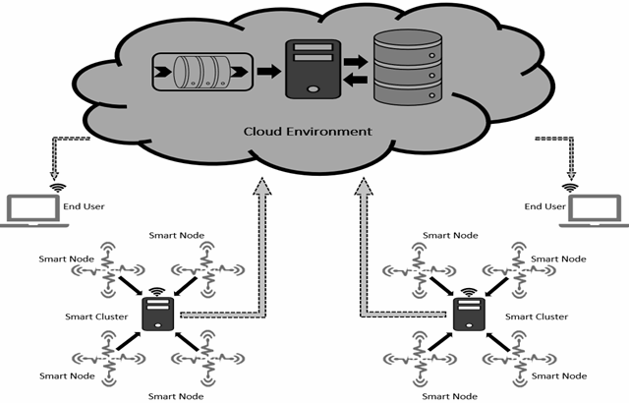

Figure : System Overview

## 

## 

## 

## 3.2 System Infrastructure and Architecture

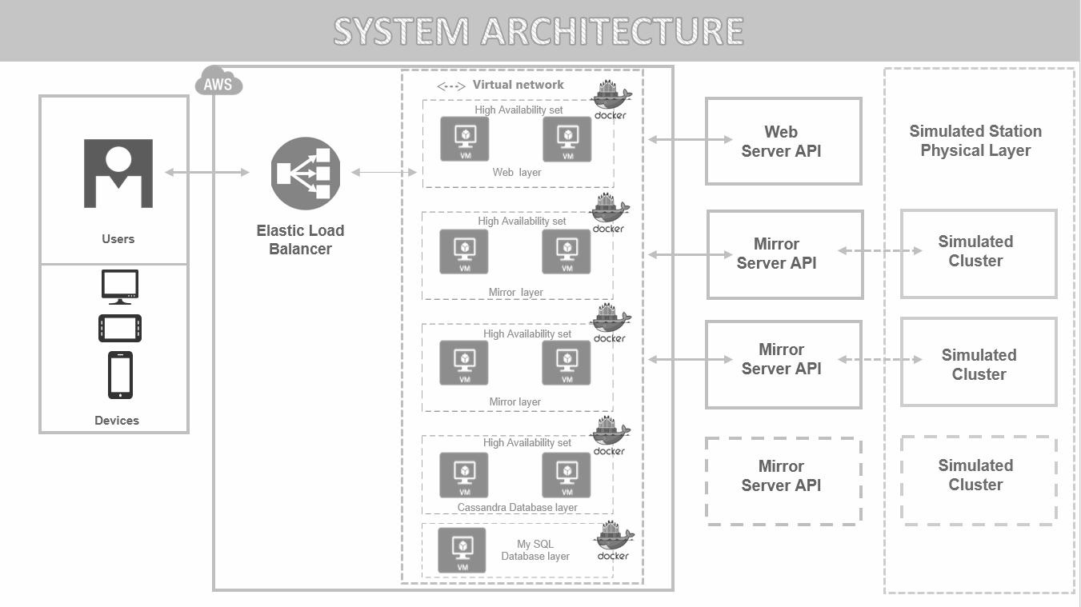

Figure : System Infrastructure

The system infrastructure has two major components:

1. Cloud based System Software Layer
2. Simulated Station Physical Layer

### 3.2.1 Cloud based System Software Layer

This layer is hosted on the AWS cloud environment and controls the entire big data sensing of the system, under use. Each Component runs in a Docker container as a docker image. The servers constituting the cloud based system are:

1. **Web Server**

This is the master server responsible for handling all cloud based activities and services by itself or by calling the respective Mirror Server.

1. **Mirror Server**

This server acts as a reflection of the simulated physical cluster in the cloud based system. There is a one to one dependency from Mirror Server to a simulated cluster station.

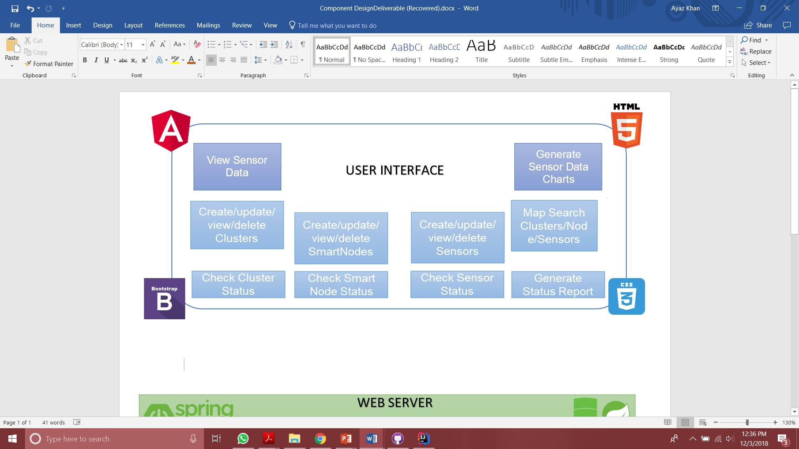

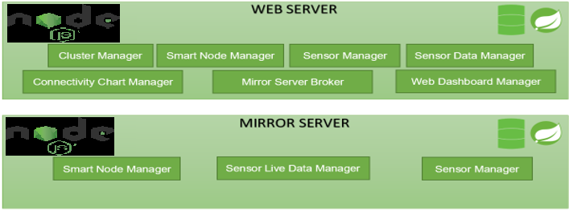

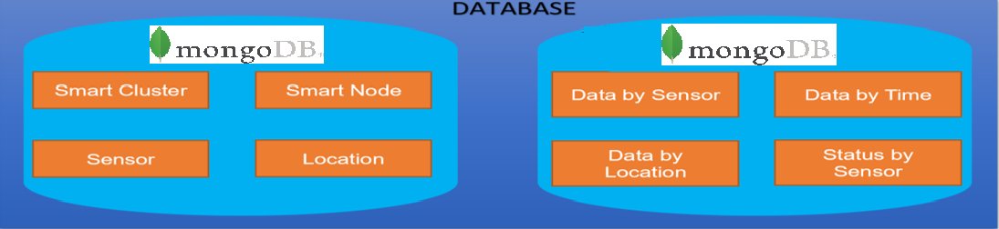

Figure : Cloud Based Solution Architecture

### 3.2.2 Simulated Station Physical Layer

Simulated Station Physical Layer is a simulated representation of the layer on the ground with real physical clusters. A physical cluster will consist of several smart nodes which will be connected to the cluster through a serial bus connection. The smart nodes shall have a set of sensors attached to them. The physical cluster shall have the connectivity to the internet required to push the big data from the sensors to the cloud.

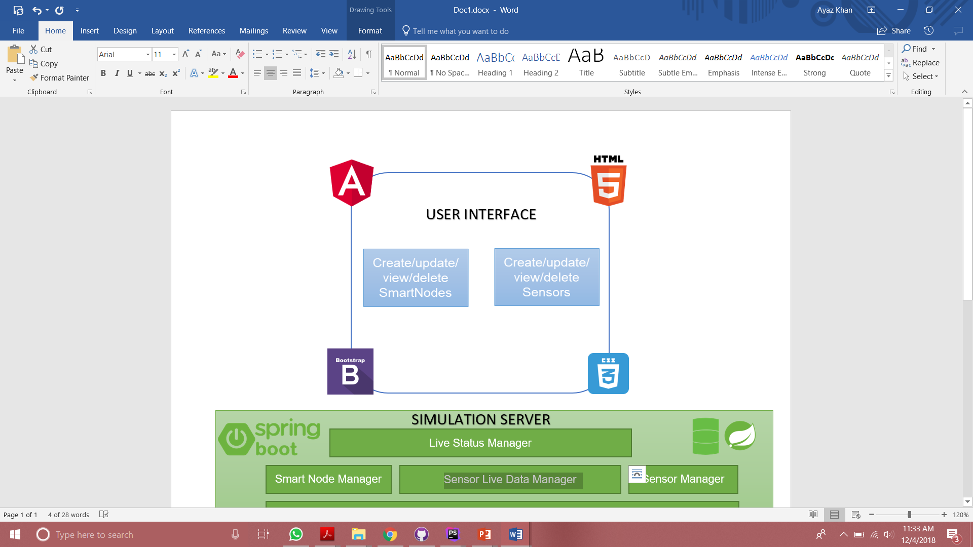

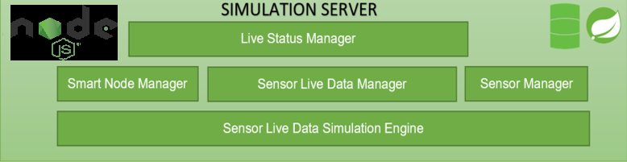

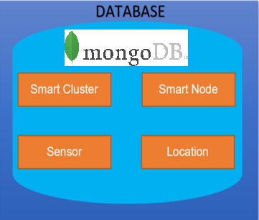

Figure : Simulated Station Solution Architecture

## 3.3 Technology Used

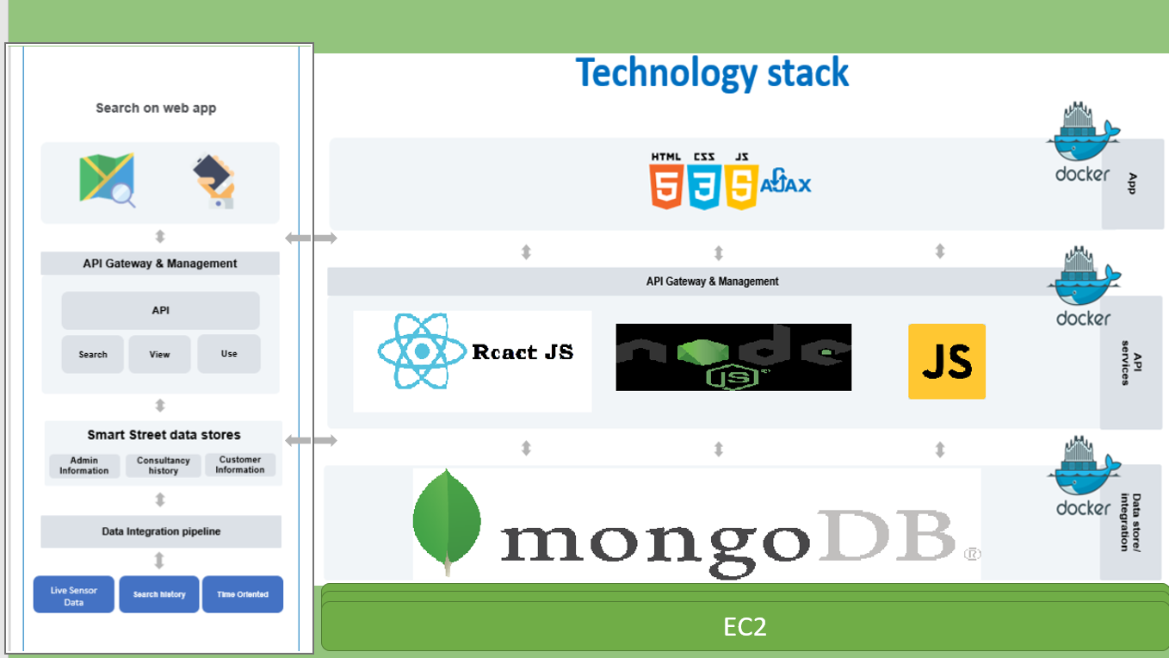

Figure : Technology Stack

## 3.4 Functional Components

### 3.4.1 Simulated Station

The major functionalities of this component are:

1. Sensor data collection – This refers to the function that collects sensor data from different sensors based on a-predefined schedule.
2. Sensor data transfer – This refers to the function that transfer sensor data to the back-end server on a cloud.
3. Smart node control – This refers to the basic control functions, such as node creation, update, deletion as well as status change.
4. Smart node configuration –This supports the configuration of a smart node, including add/delete/update/set-up a list of sensors.
5. Smart node and sensor status collection and transfer.

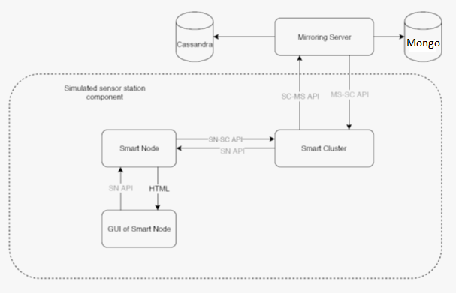

Figure : Simulated Station API Design

### 3.4.2 IOT Based Infrastructure Manager

The major functionalities of this component are:

1. Cluster node management:

add/update/delete/view cluster nodes and track cluster status.

1. Smart node management:

add/update/delete/view smart nodes controlled by a cluster, and track node status.

1. Sensor management:

add/update/delete/view sensors from a selected smart node sensor, and track sensor status.

1. Display and generate a status report on an existing IOT smart ranch infrastructure.

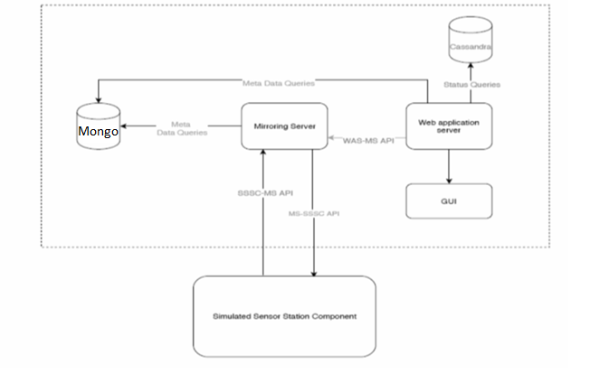

Figure : IOT Based Infrastructure Manager API Design

### 3.4.3 IOT Based Data Manager

The major functionalities of this component are:

1. It collects sensor data from the smart cluster at regular intervals of time.
2. Retrieve sensor data for a smart node based a given time range (year/month/week/date), and display them in a table view.
3. Retrieve senor data for a cluster node based a given time range (year/month/week/date), and display them in a table view.
4. cloud connectivity chart which shows the connectivity between all of stations and the back-end server.

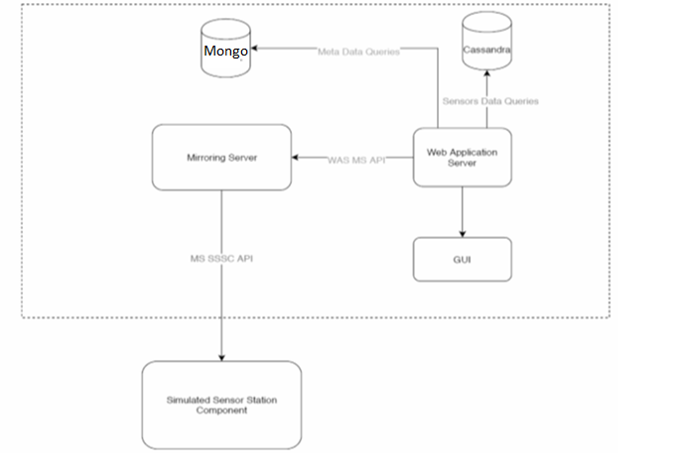

Figure : IOT Based Data Manager API Design

### 3.4.4 System Dashboard Manager

This is a graphic user interface component for your system. It must include the following common functions:

1. It must provide some statistics information about your smart street infrastructures in a smart city.
2. A map-based user interface, which allows users to select a region, such a city, zip code, or a selected region to access the following features:
3. discover and display smart nodes and cluster nodes for a smart street in a city using a map.
4. discover and display the statistics information your smart nodes/clusters and their connections in smart street
5. discover and display the statistics information about the underlying sensor data in a selected time range.

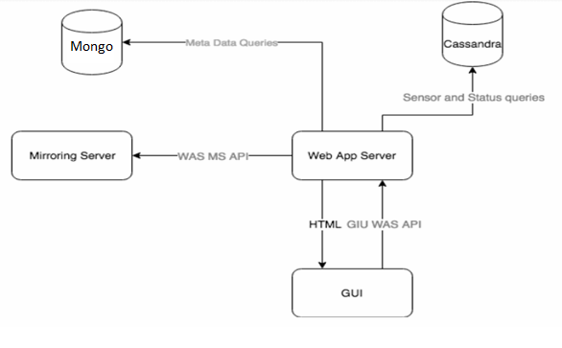

Figure : System Dashboard Manager API Design

# 4. Large-Scale IOT Data Design and Implementation

## 4.1 IOT infrastructure DB design and implementation

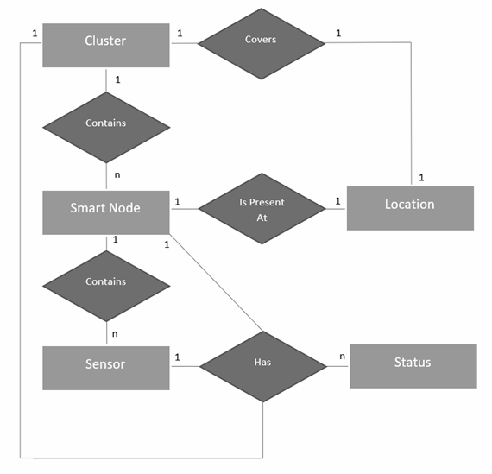

Figure : Entity Relationship Diagram

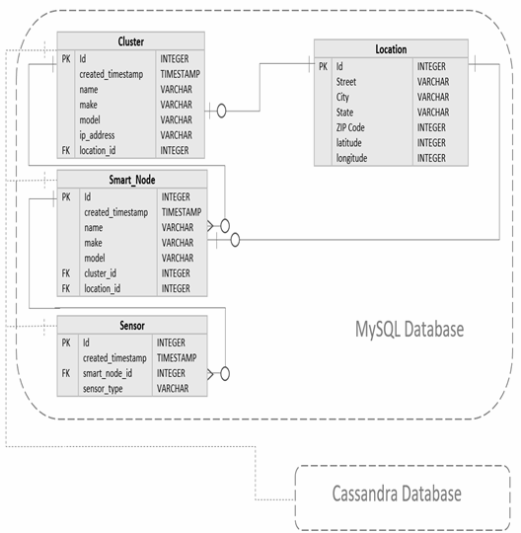

Figure :MySQL Database Design

All the MySQL database queries have been auto generated by Spring Data interface.

## 4.2 IOT sensor DB design and implementation

**4.2.1 Cassandra Database Design**

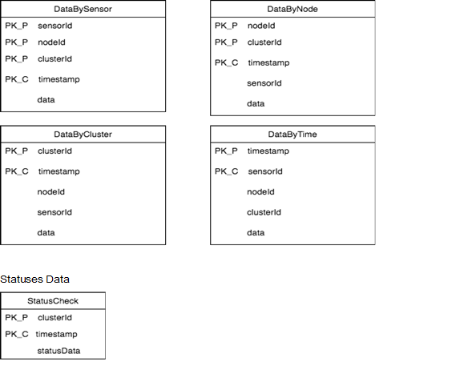

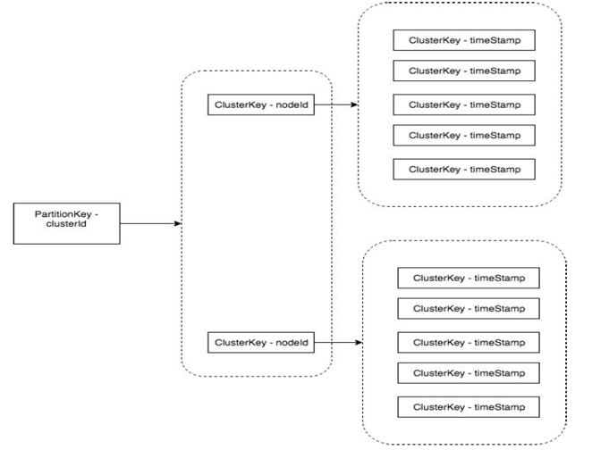



This DB dedicates to store:

Sensors time series data

Smart Nodes statuses data

In order to organize the Cassandra data schema, there is a need to define a Partition Key and Cluster Key.

Partition Key - multiple table columns which determines which node stores the data

Cluster Key - A cluster index is an index structure that contains the values of the cluster key, the column or columns that link the tables in the cluster together. The cluster index is more than just a way to optimize retrieval

IOT Database (Cassandra) responsibility:

1) Store Sensors Data and Health Data

2) Provisioning different types of searching requests

3) Provisioning good horizontal scalability

4) Sensors time series data.

Sensor data by cluster for time range specified query

**SELECT * FROM sensor_data_by_cluster WHERE idSmartCluster = :idSmartCluster AND timestamp > :from AND timestamp < :to**

Sensor data by node for time range specified query

**SELECT * FROM sensor_data_by_node WHERE idSmartNode = :idSmartNode AND timestamp > :from AND timestamp < :to**

Sensor data by sensor for time range specified query

**SELECT * FROM sensor_data_by_sensor WHERE idSensor = :idSensor AND timestamp > :from AND timestamp < :to**

# 5. IOT-based cloud system design and services

## 5.1. System Services

The system services can be categorized into five major functional services:

### 5.1.1 Simulated Station Services

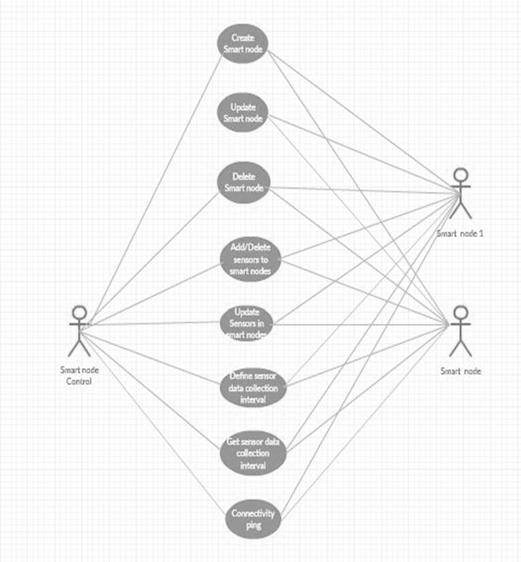

Figure :Simulated Station Use case Diagram

Sensor Node Configuration:

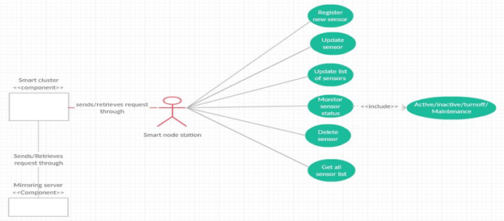

**Sensor Data Collection:**

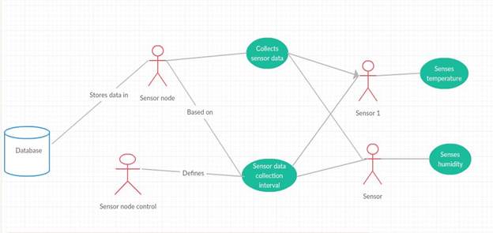

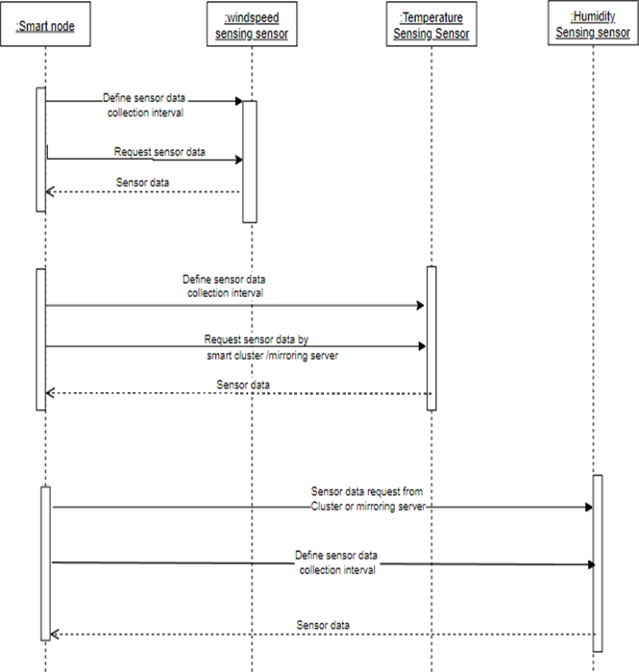

Figure : Simulated Sensor Service Sequence

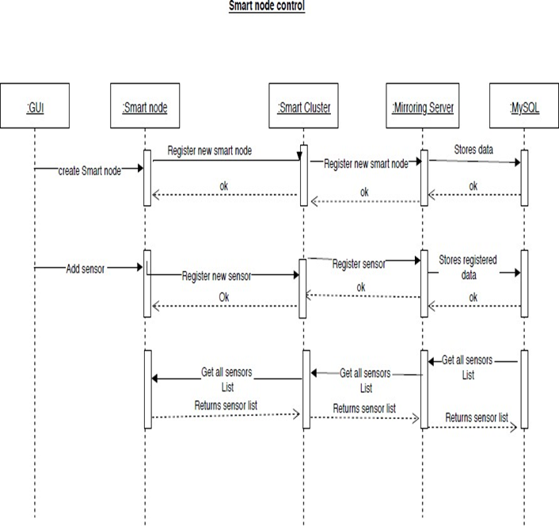

### 

Figure : Simulated Sensor Service Sequence

### 

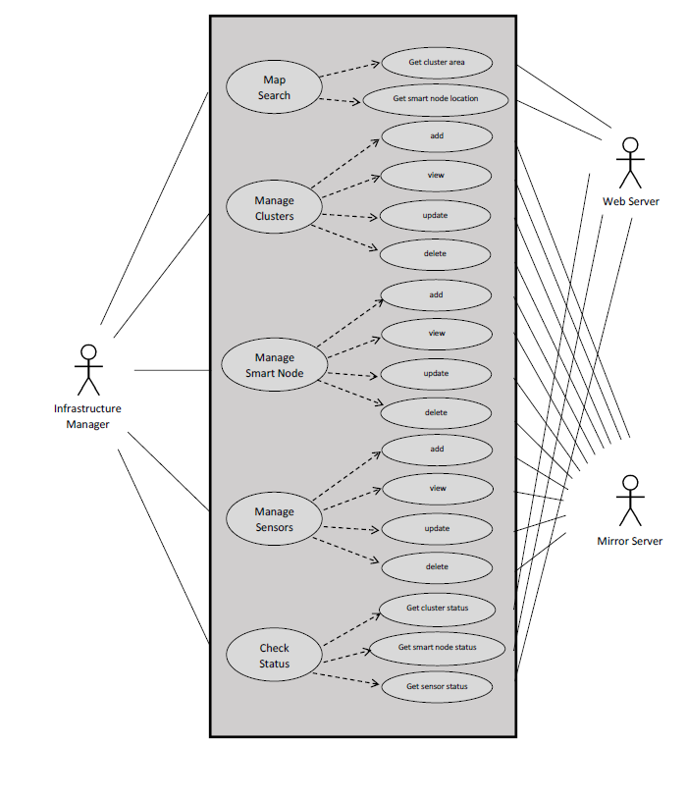

Figure : Infrastructure Manager Services

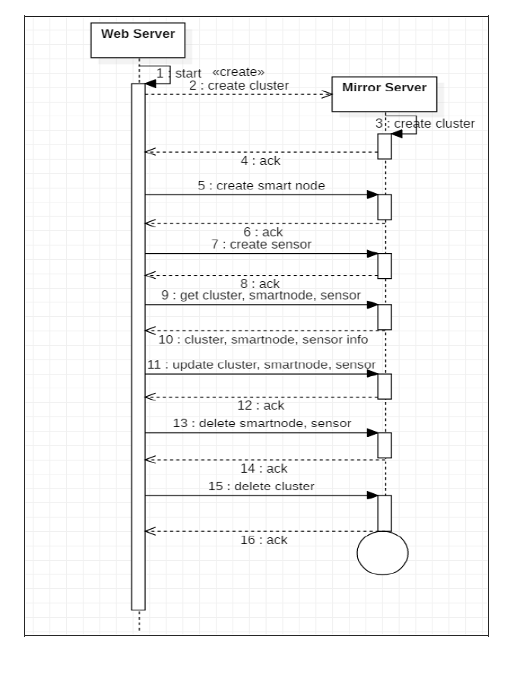

Figure : Infrastructure Manager Service Sequence

### 5.1.3 Data Manager Services

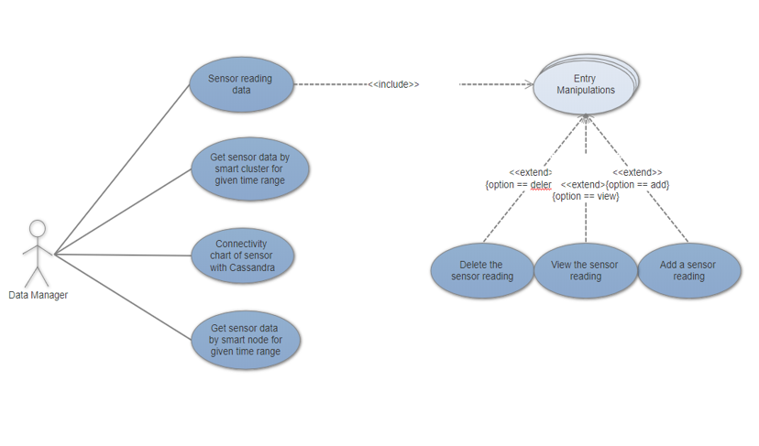

Fig: Data Manager Use Case Diagram

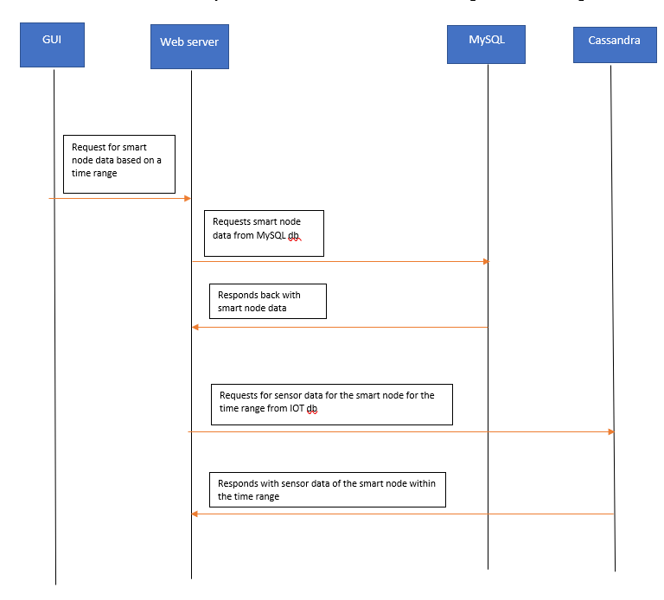

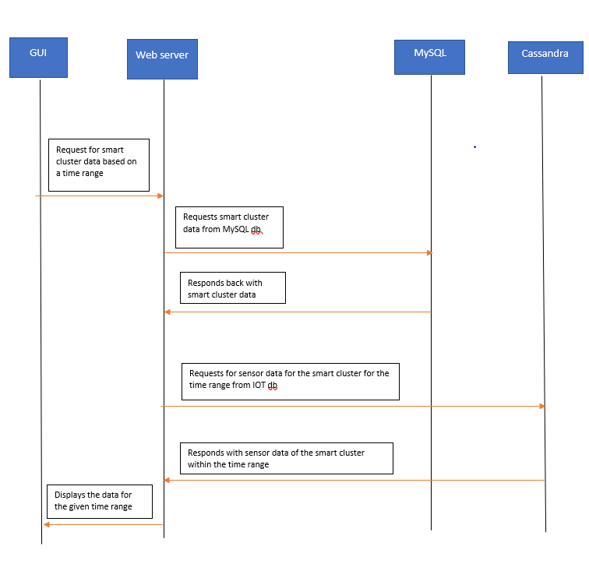

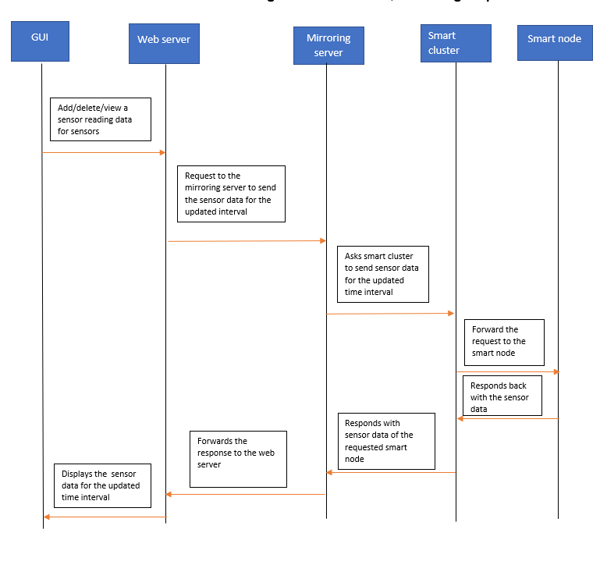

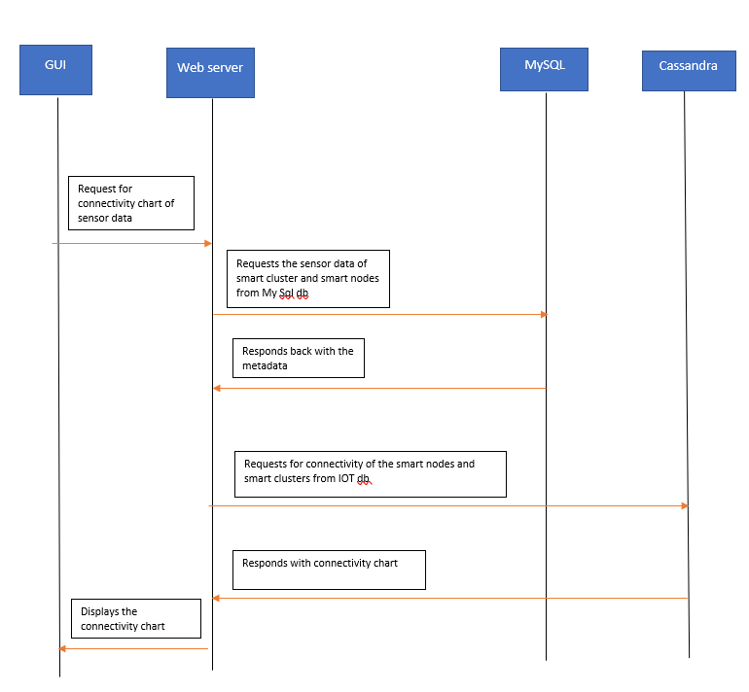

### 

### 5.1.4 System Dashboard Manager Services

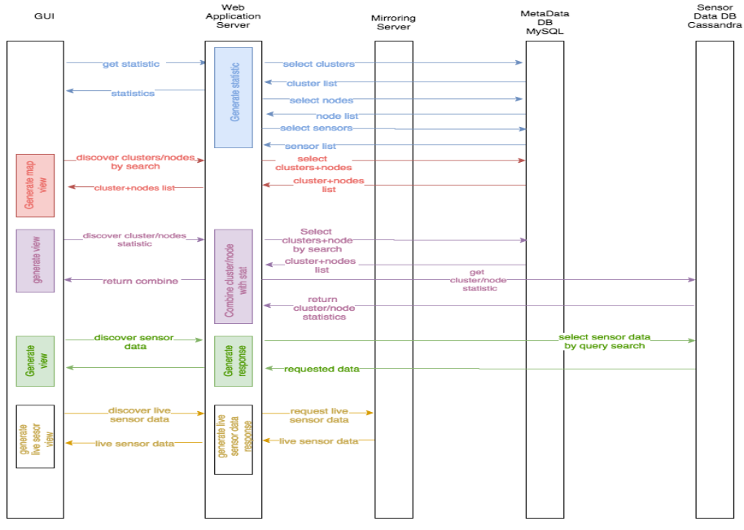

## 5.2 System Scalability Design and Implementation

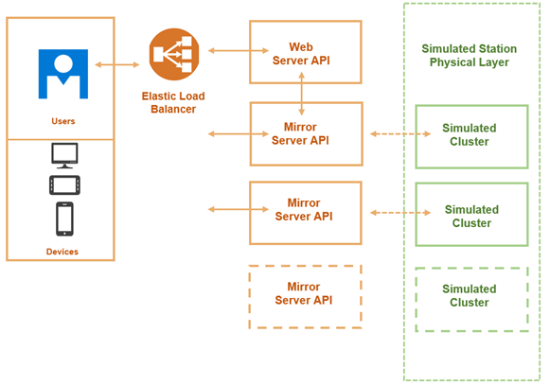

Our scalability can be seen in the following points:

1. The part of the system scalability is that we have mirroring server for each real cluster. That means when we add more physical clusters our system will receive additional mirroring server and will never be overloaded.
2. The second element is that we have stateless web-server cluster, that means we can add mode web-server nodes into cluster in terms to respond to increased payload.
3. The third element is the Cassandra clusterization, we can horizontally scale the Cassandra cluster to support very big data set.

## 5.3 System Load Balance Design and Implementation

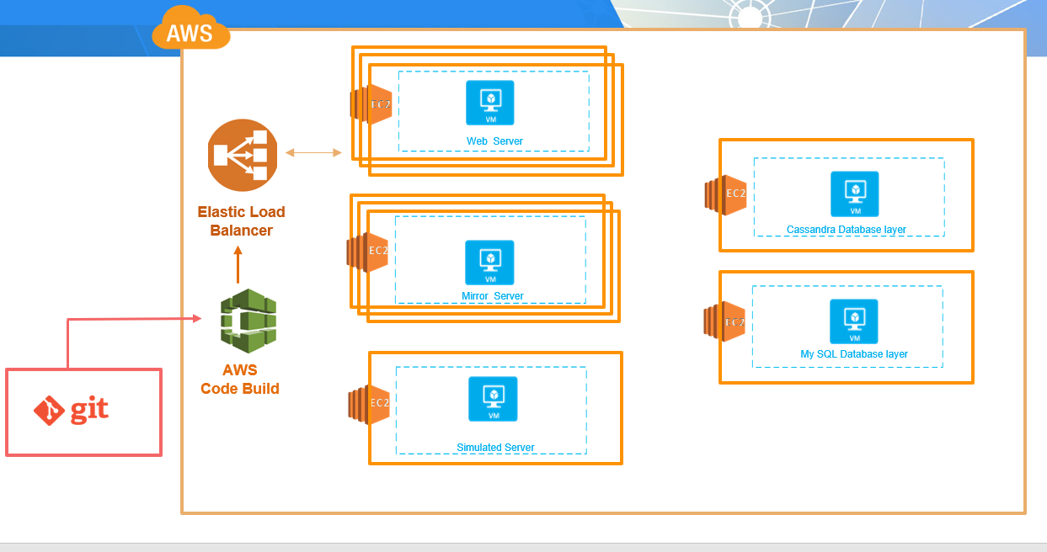

# 6. System GUI Design and Implementation

System GUI consist from the following elements:

* Home page
* Terms page
* Contacts page
* Dashboards

Dashboards contain:

* User dashboard
* IoT manager dashboard
* Data manager dashboard

*User dashboard* has the following pages:

* Statistics view
* Map view
* Connectivity view
* Sensor Data view

IoT manager dashboard has the following pages:

* List of Smart Clusters
* Smart Nodes view

Data manager dashboard has the following pages:

* Sensor Data by Cluster view
* Sensor Data by Node view
* Sensor Data by Sensor view
* Connectivity Chart

## 6.1 Home Page

Home page devoted to the general information about the Smart Street project, can include some links to the external resources about the project conceptions.

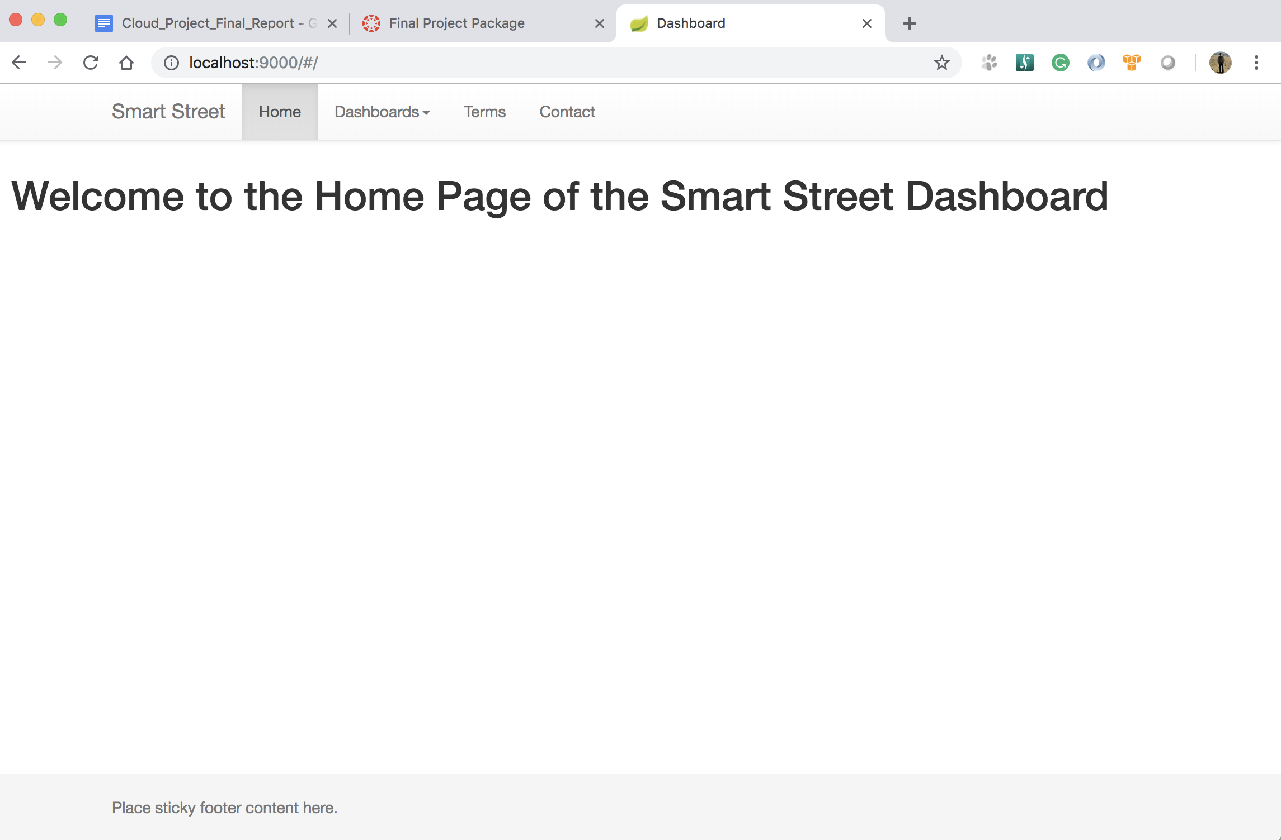

## 6.2 Terms page

The terms page should contain the terms of the service usage, some agreements and responsibilities (user and service).

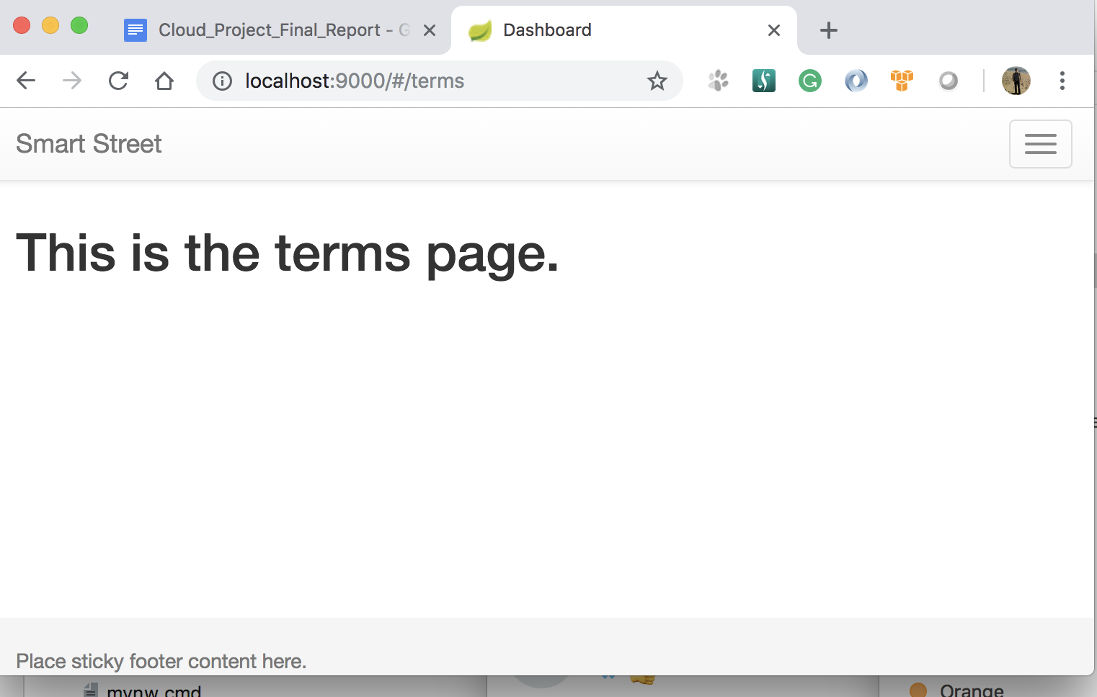

## 6.3 Contacts Page

This page will contain the contacts endpoints for the Customer service, office location and any other administrative information.

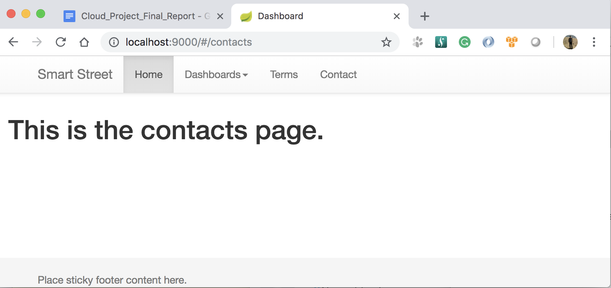

## 6.4 Dashboards

### 6.4.1 User Dashboard

User dashboard provide the system information about Sensor network as statistics, map view of the network elements, connectivity statistics and sensors data chart.

*Statistics Page*

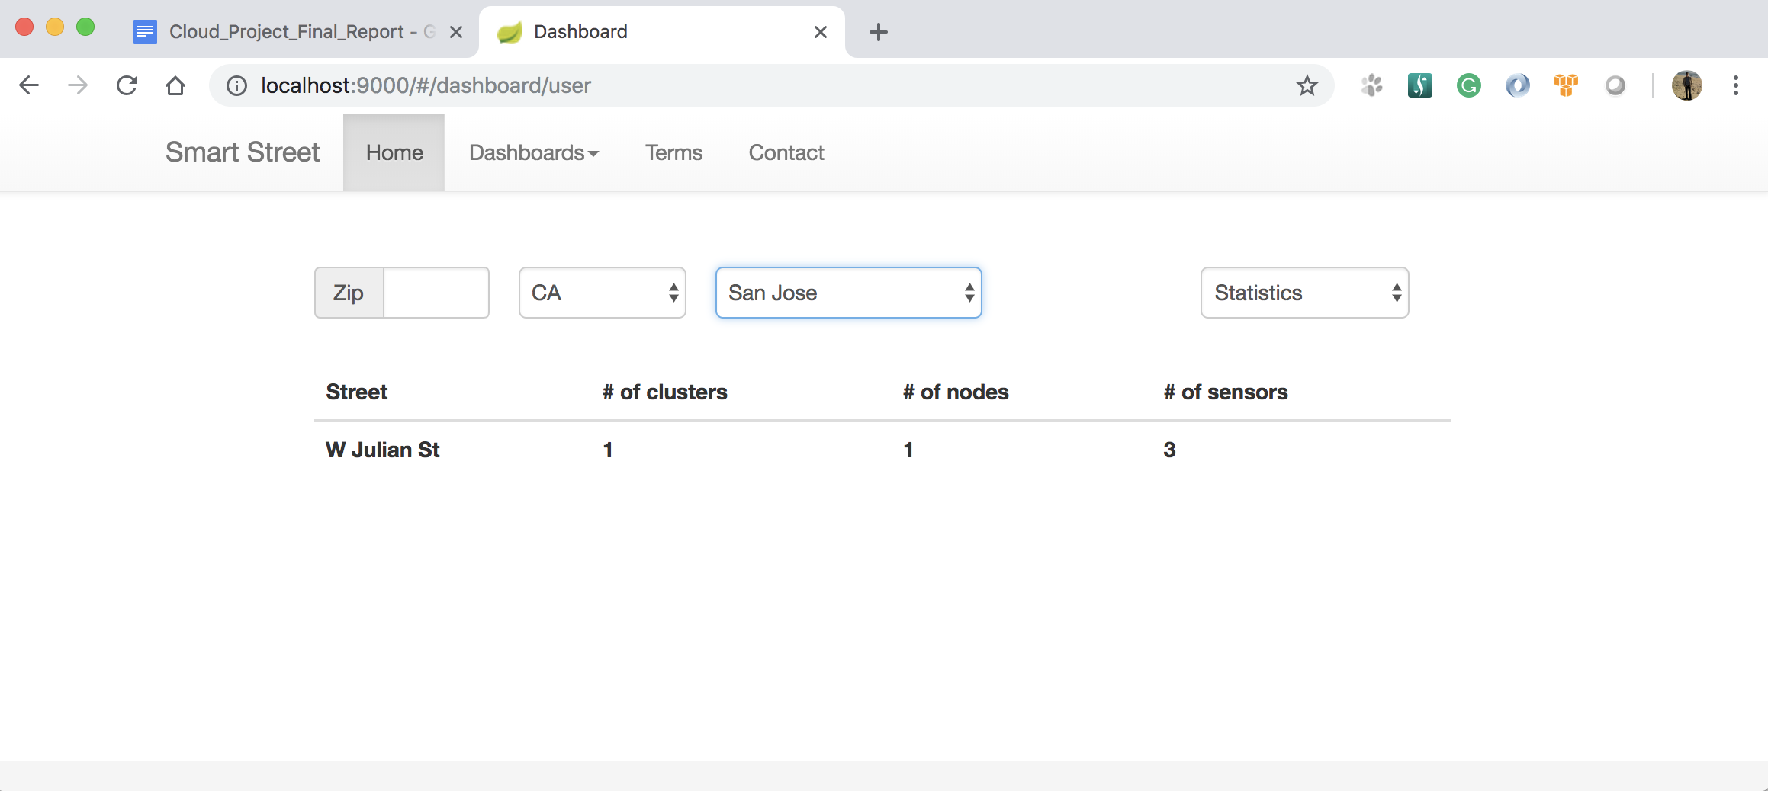

*Map view*

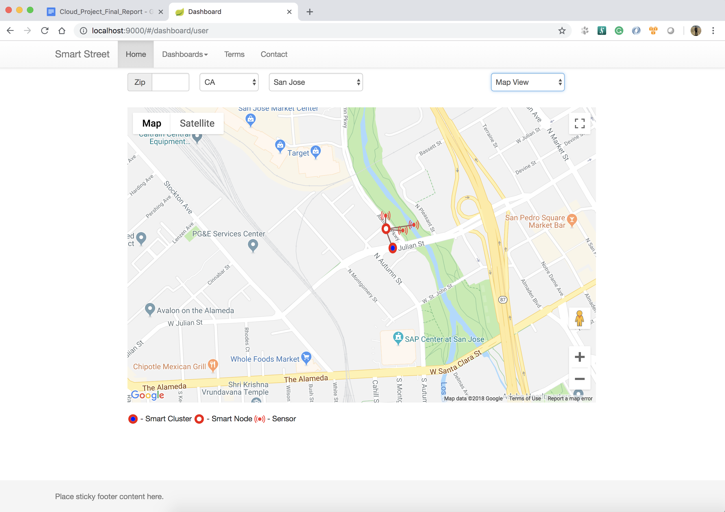

*Connectivity view*

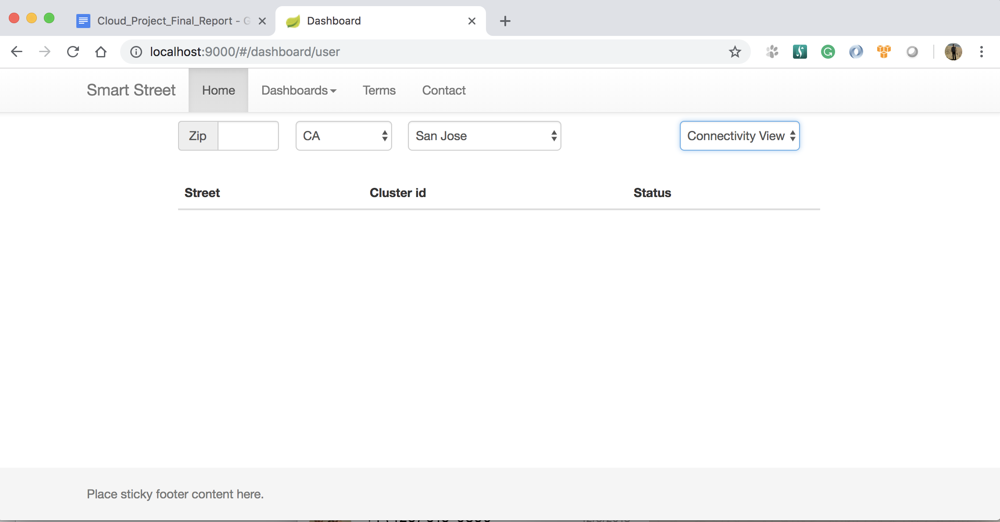

*Sensor Data view*

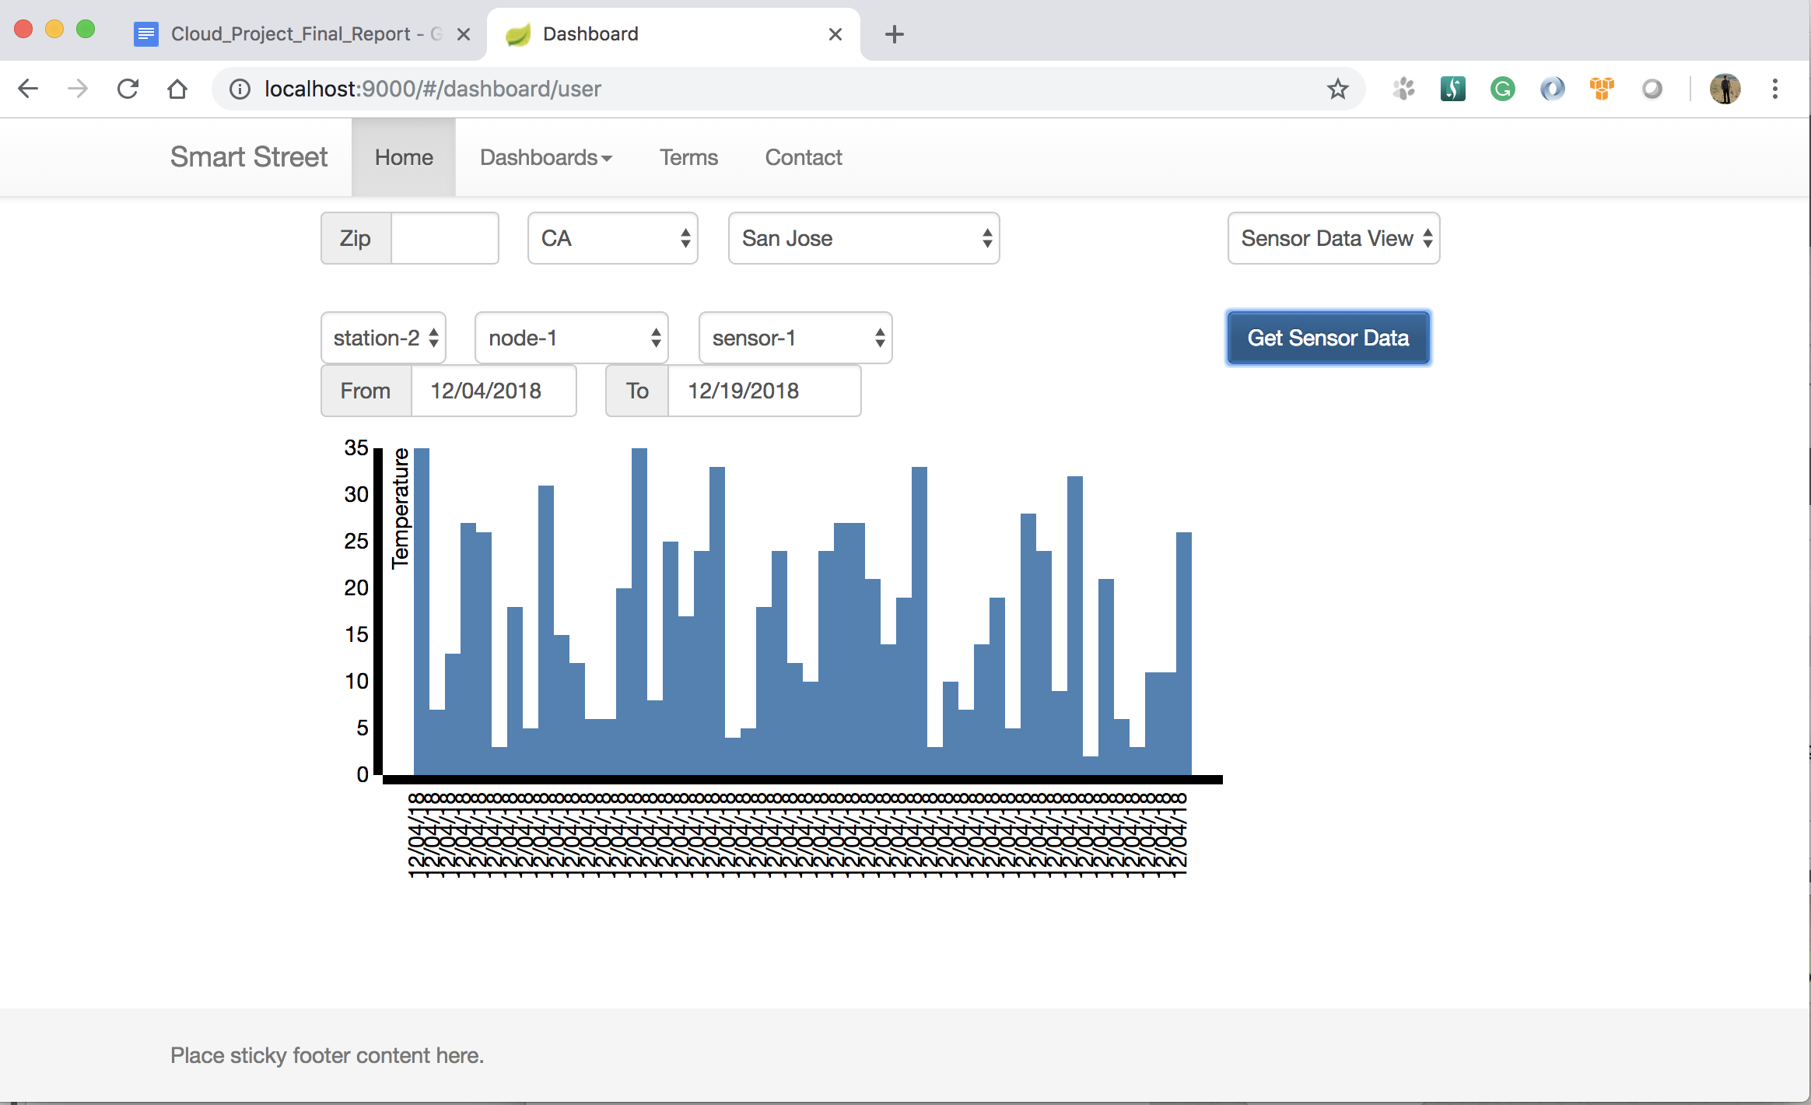

### 6.4.2 IoT manager dashboard

This dashboard belong to the IoT manager role. Using this dashboard manager will be able to manage Sensor network infrastructure as create, update, delete such elements as clusters, nodes and sensors.

*List of Smart Clusters*

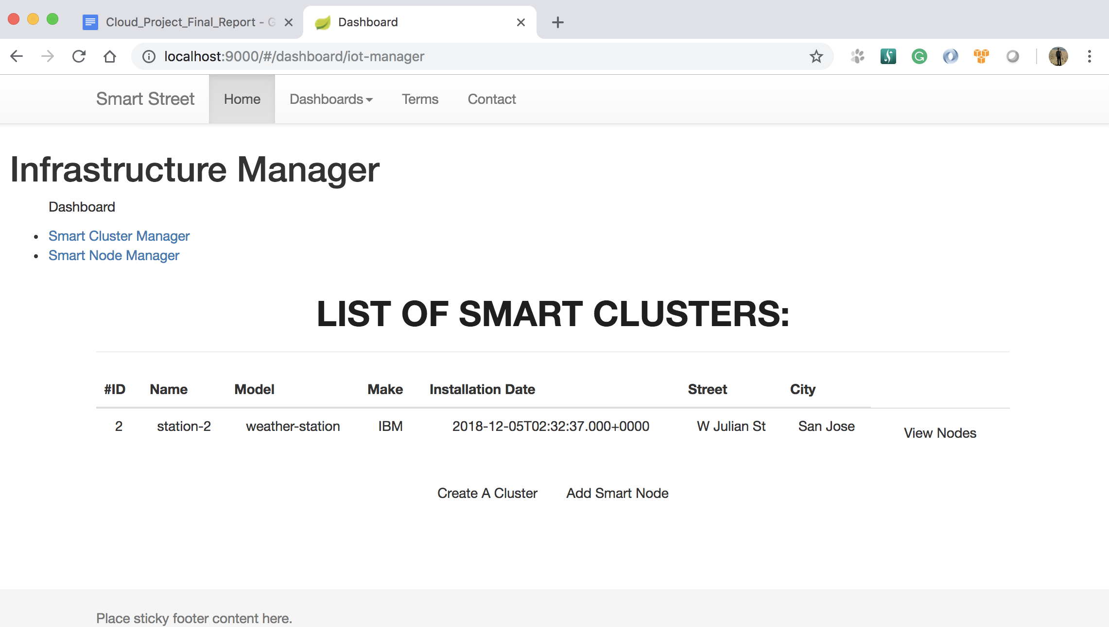

*Smart Nodes view*

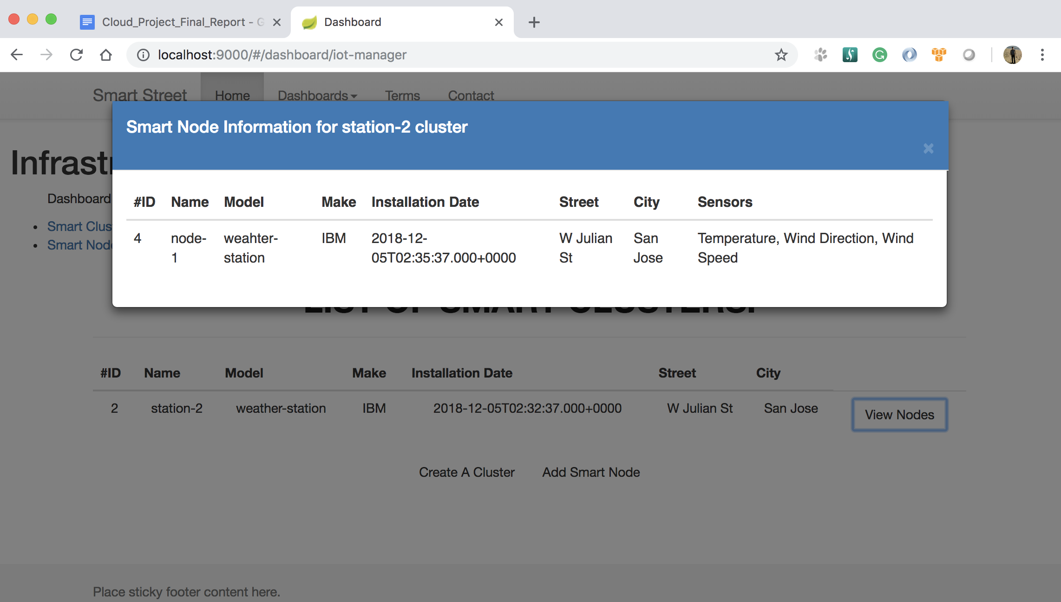

**6.4.3 Data manager dashboard**

Data manager dashboard allow to manager do operations under data as get, delete, define the data collection intervals and connectivity statistic collecting intervals.

*Sensor Data by Cluster view*

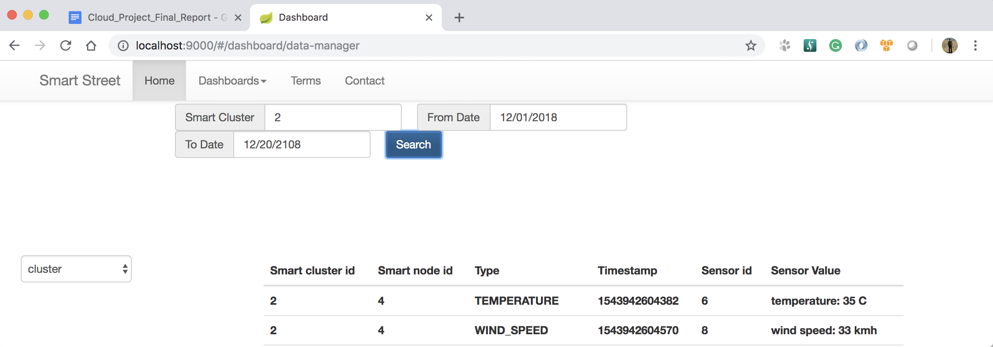

*Sensor Data by Node view*

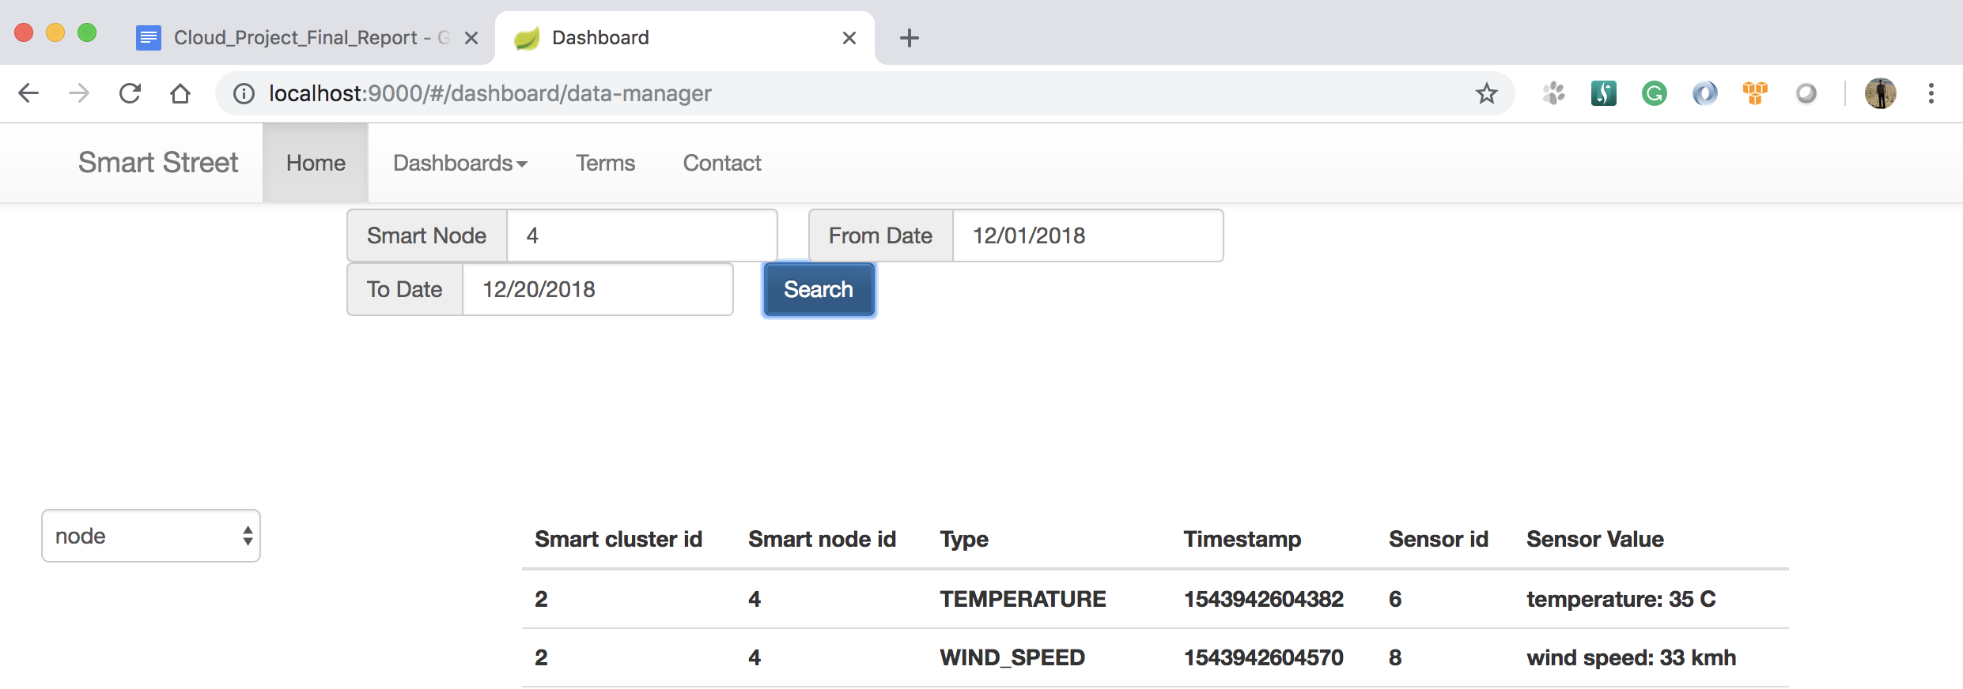

*Sensor Data by Sensor view*

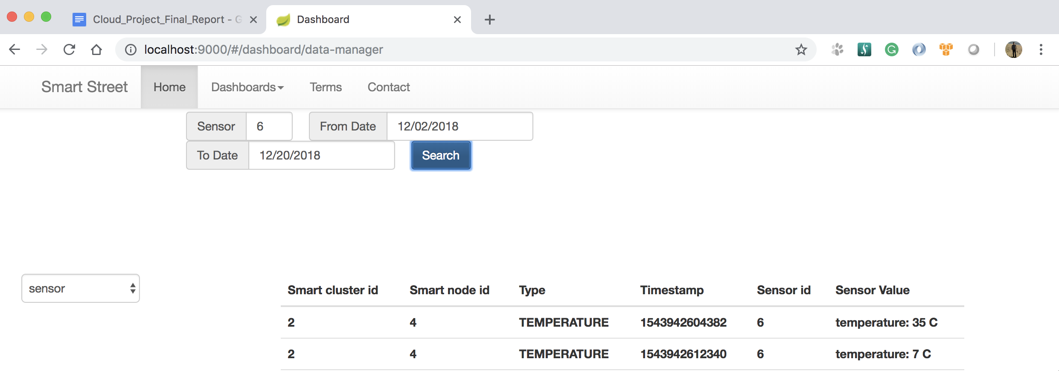

*Connectivity Chart*

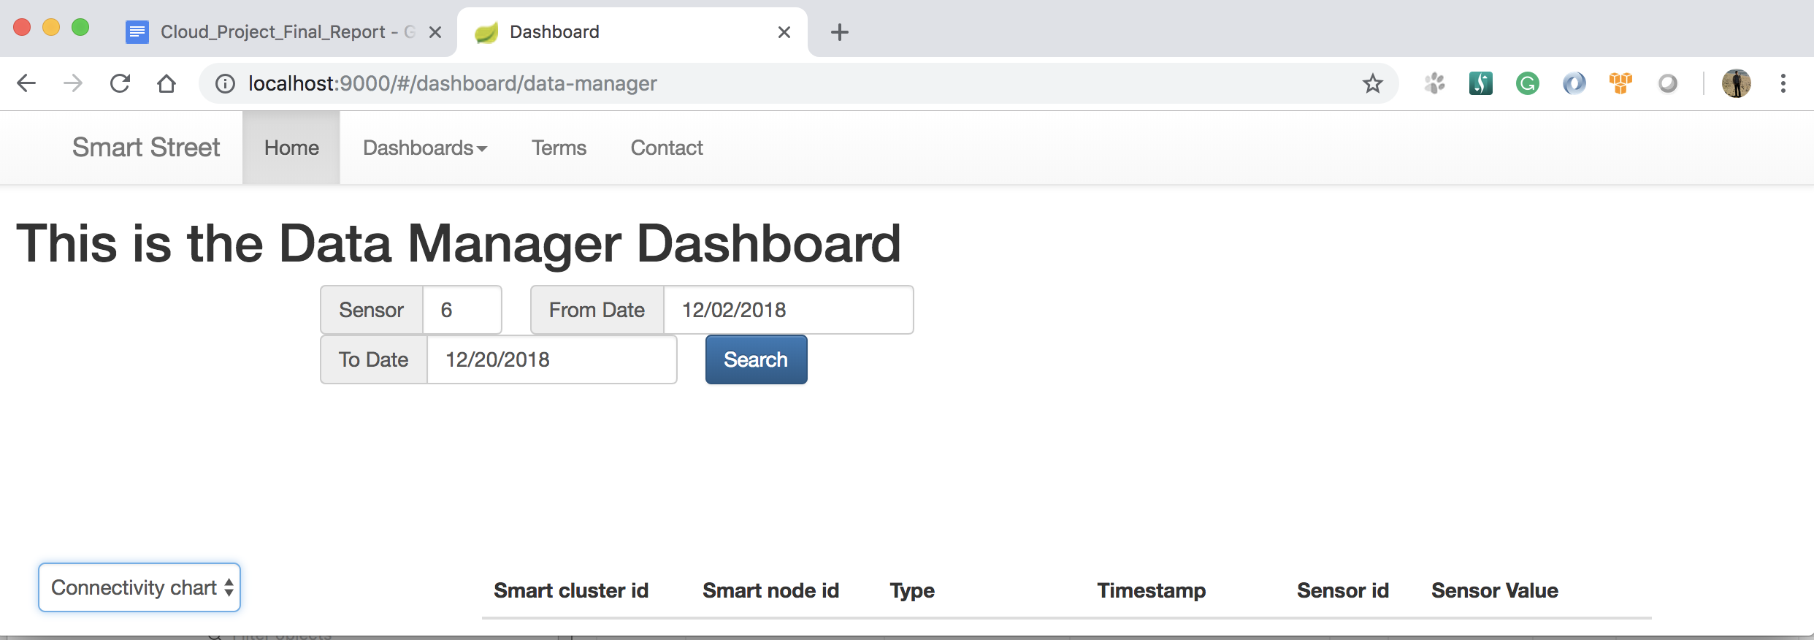

# 7. Edge Station Design and Simulation

## 7.1 Simulated Station API Design

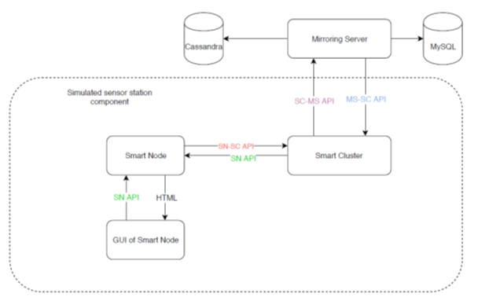

## 7.2 Simulated station Functionality

Simulated station has the following functions:

* Smart Cluster Creation.
* Smart Cluster GUI creates the Smart Cluster.
* Smart node Creation,Updation,Deletion.
* Smart nodes are created, updated, deleted using the node manager GUI .
* Sensor Creation,Updation,Deletion.
* Each smart node contains three sensors , temperature sensor,wind speed sensor and wind direction sensor respectively.They are configured while the smart nodes are created.
* Send status of smart nodes/smart clusters/sensors to data manager or infrastructure manager at a scheduled time interval.
* Manages Live sensor data.
* Maintains and sends Live status of sensors and smart nodes.
* Generates sensor data i.e. temperature, wind speed, wind direction values randomly when the data needs to be produced.

## 7.3 Simulated Station GUI design and Flow:

**• A Smart cluster is created with an SmartClusterid using the Simulated station GUI.**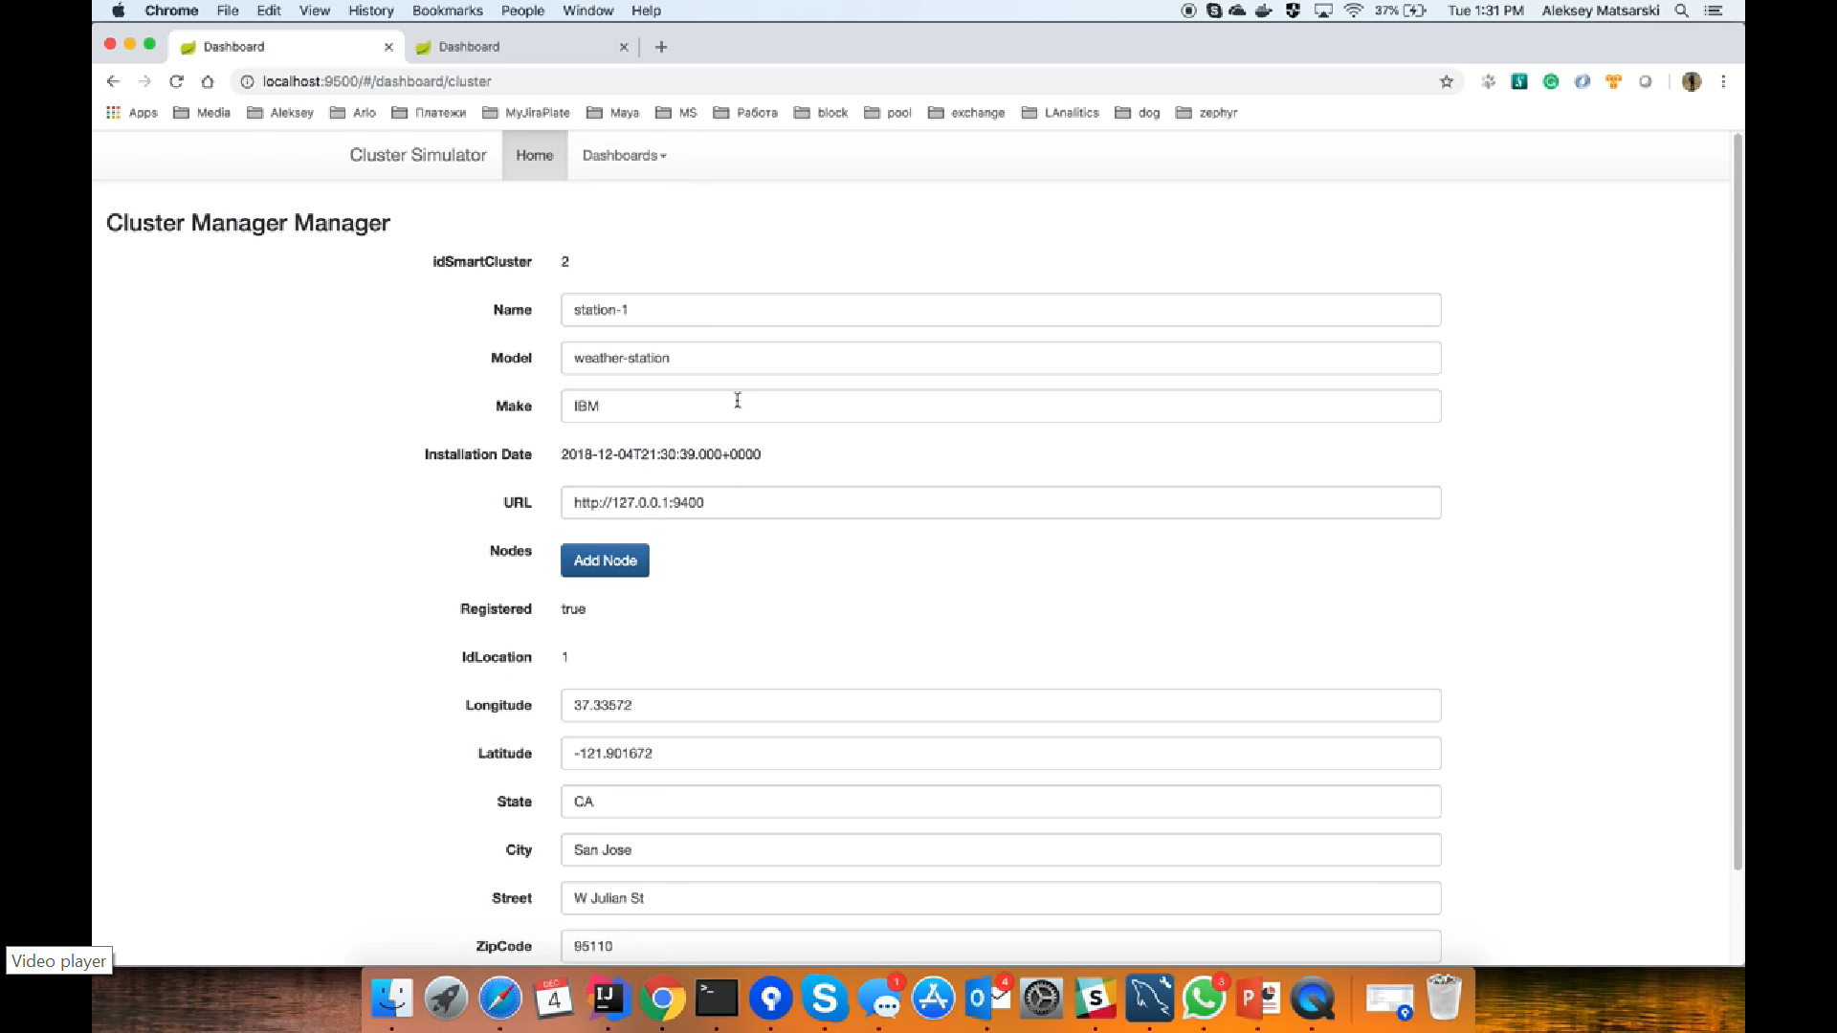

**Now the Smart Cluster is saved in the database.**

* **A Smart Node is added to the Smart Cluster by clicking the Add node option as shown below.**

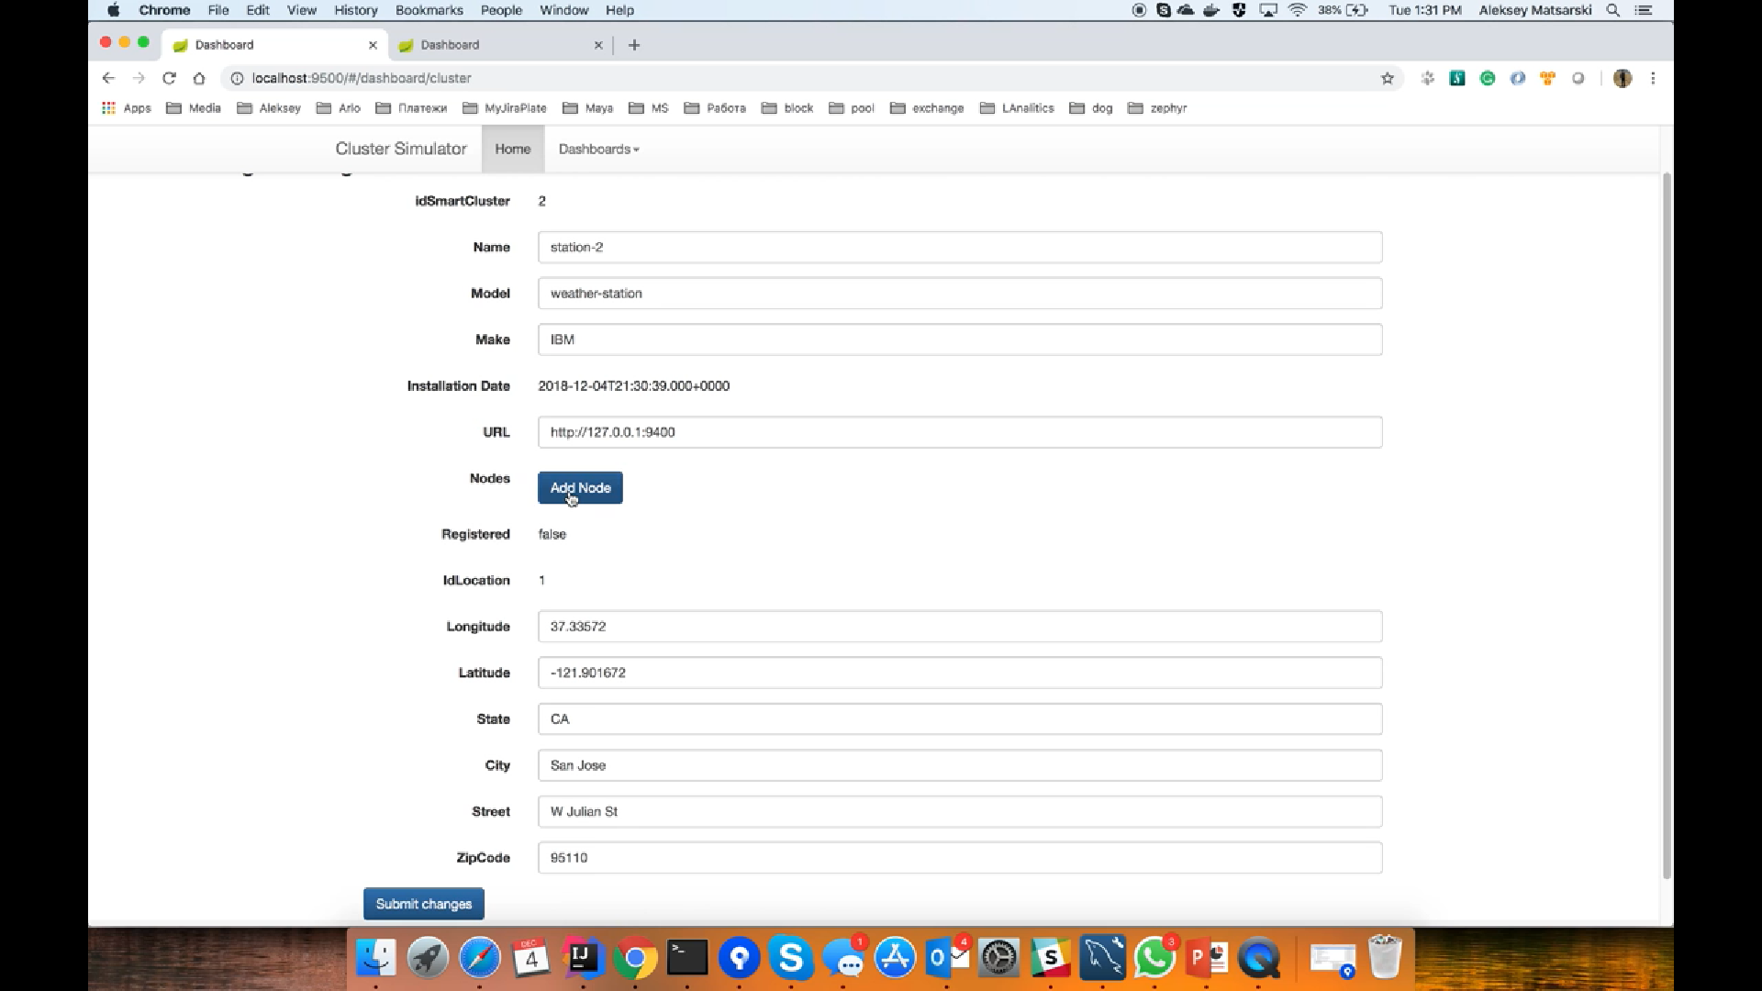

* **Now a dialogue box appears to enter the details of the smart node that we are going to add into the smart cluster.**
* **After Entering the details ,submit option adds the smart nodes to the smart cluster .We can add as many smart nodes as we want to a smart cluster.**

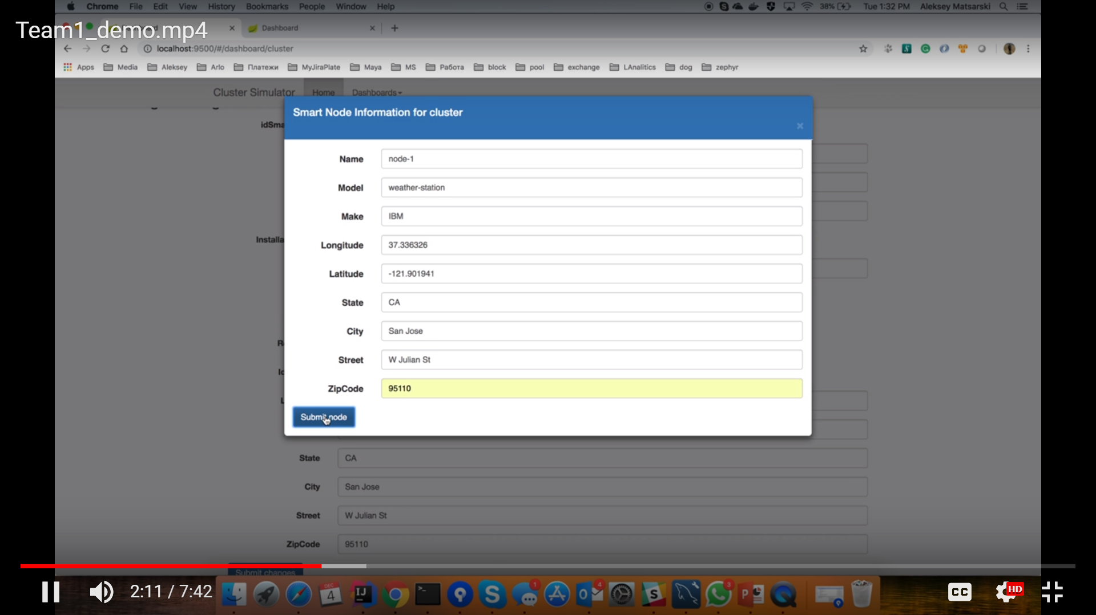

* **Now the smart node is created.And now the sensors to the smart nodes are added at the time when the smart node is created.**
* **Each smart node has three sensors, temperature sensor, wind speed sensor, wind direction sensor respectively.**

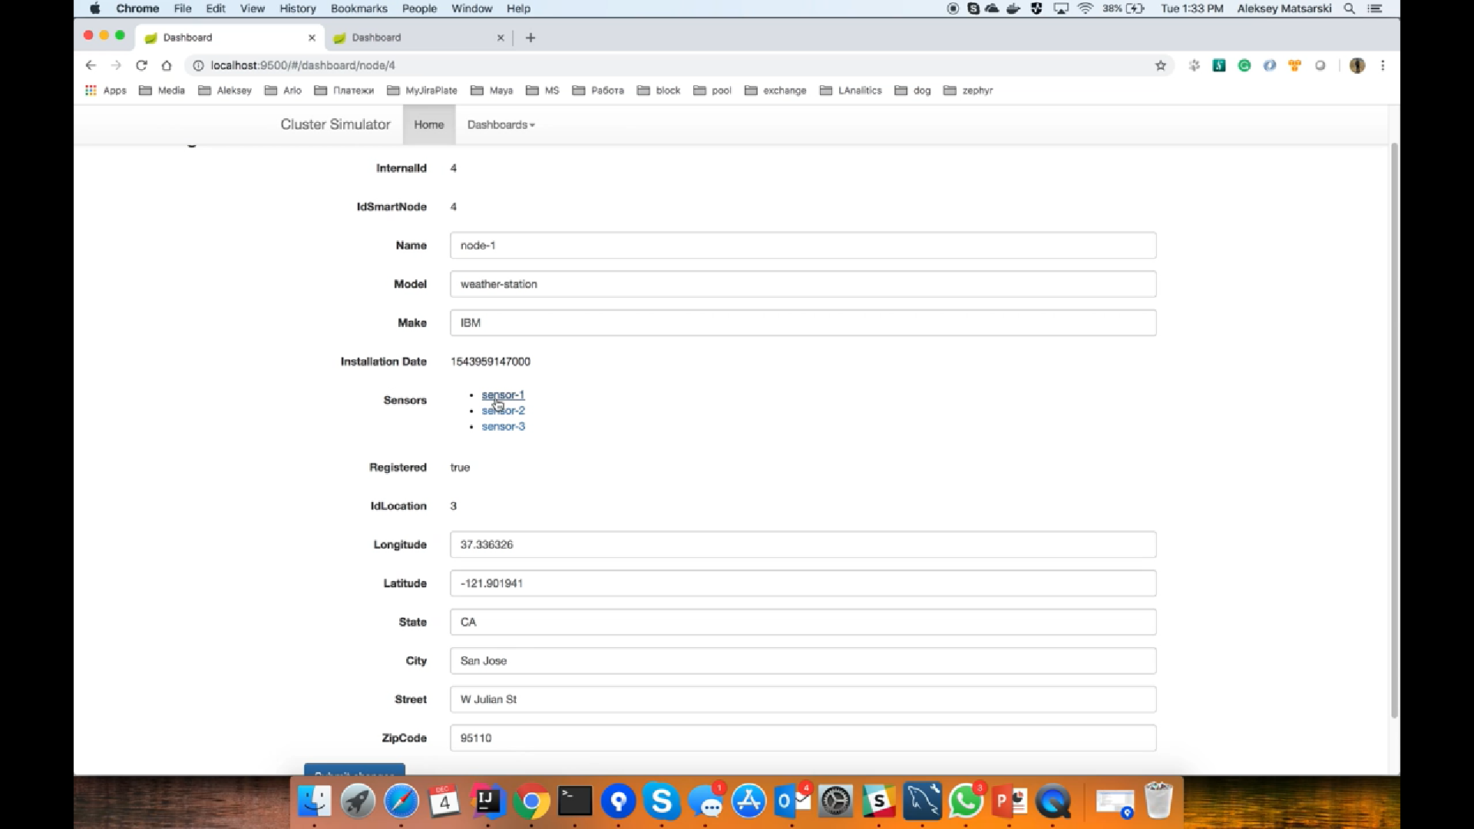

**Wind Speed Sensor Details**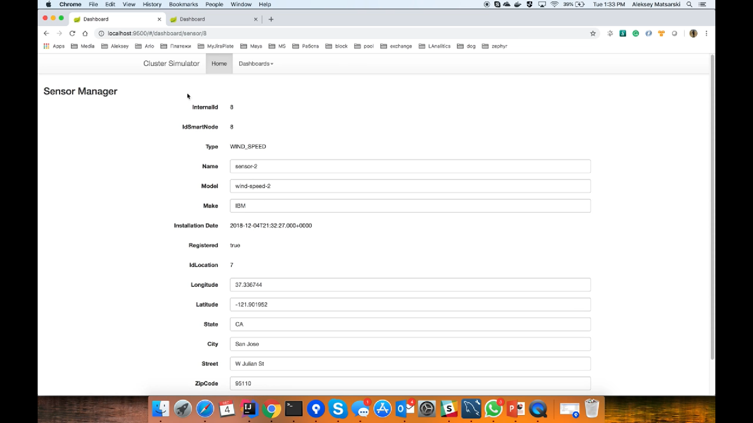

**Temperature Sensor Details**

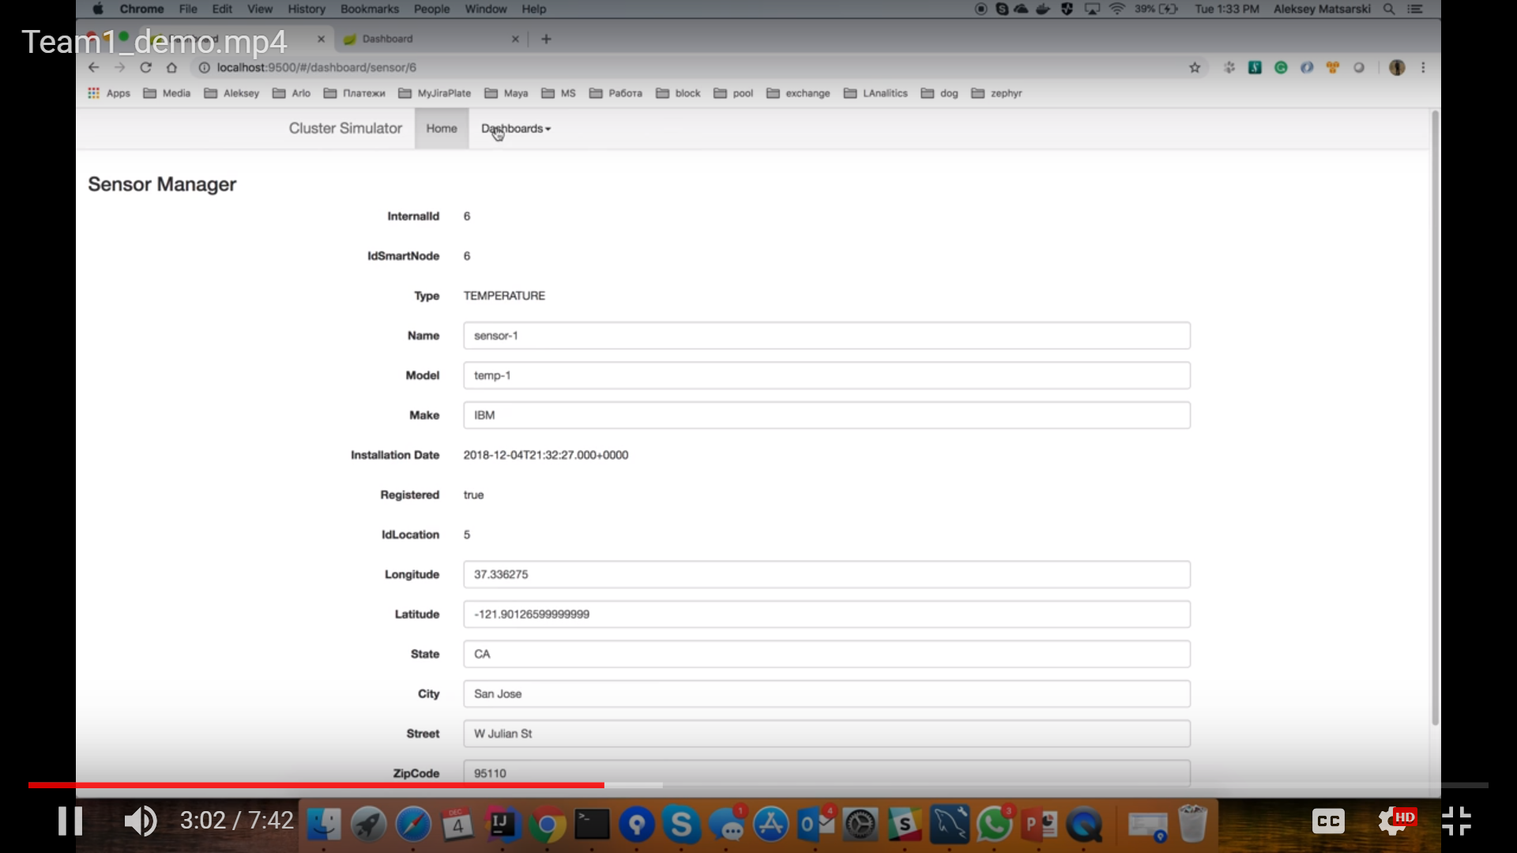

**Wind Direction Sensor Details.**



**8. Conclusion**

While working on this project the different kind of experience and lessons were learned.

*Technical experience*

The following conceptions were learned:

* Sensing cloud network;
* IoT device interaction principles;
* System architecture design principles (component oriented architecture);
* Software architecture design principles (MVC principles, service and module oriented architecture);
* Big Data beginning knowledge (when used, how to partition the data and scalable DB).

The following technologies and frameworks were applied:

* Java
* Rest API;
* JSON data format;
* Spring boot framework (Java based framework);
* Logback logging system
* MySQL DB and query language;
* Cassandra DB, cassandra query language, clasterisation, partitioning;
* Thymeleaf server-side Java template engine;
* JavaScript scripting language for front-end development
* AngularJs front-end MVC framework;
* Bootstrap front-end framework for visual components.
* Docker technology (image and container creation)
* Bamboo code builder and deployment tool
* Grunt scripting language for deployment script
* AWS console services (Ec2 service, Elastic IP service, Load Balancing service)

*Teamwork and collaboration experience*

The project has provided our team with an opportunity to develop the following skills and techniques:

* Project management skills: appropriate work scope partition and distribution among the team management according to each team member’s professional expertise and knowledge;
* Scheduling and running ongoing team meetings for various operational and strategic decisions, e.g. planning the work to meet project deadlines and terms;
* Brainstorming ideas, as well as supporting each other and providing safe space for sharing various solutions;
* Troubleshooting issues in the code area and searching for the existing solutions on the technical community websites.

**REFERENCES**

[1] An IOT-based smart street infrastructure management system on a cloud, Jerry Gao, Ph.D, Fall, 2018, 9/04/2018

[2] Smart city, Wikipedia, the free encyclopedia, https://en.wikipedia.org/wiki/Smart_city

[3] Peris-Ortiz, Marta; Bennett, Dag R.; Yábar, Diana Pérez-Bustamante (2016). Sustainable Smart Cities: Creating Spaces for Technological, Social and Business Development . Springer. ISBN 9783319408958 .

[4] Jerry Gao, Lihui Lei and Shui Yu,”[Big Data Sensing and Service: A Tutorial](https://ieeexplore.ieee.org/document/7184867)” in IEEE First International Conference on Big Data Computing Service and Applications, 2015